The concrete *Diplodocus* of Vernal

**Michael P. Taylor.** Department of Earth Sciences, University of Bristol, Bristol BS8 1RJ, UK. [dino@miketaylor.org.uk](mailto:dino@miketaylor.org.uk) (corresponding author)

**Steven D. Sroka.** Utah Field House of Natural History State Park Museum, 496 E. Main Street, Vernal, UT 84078.

**Kenneth Carpenter.** University of Colorado Museum, Boulder, CO 80309.

**Abstract**

Although many casts have been made of the iconic Carnegie *Diplodocus*, initially in plaster and more recently in various plastics, one stands alone as having been cast in concrete. This skeleton, made from the original Carnegie molds starting in 1956–7, was unveiled at the Utah Field House of Natural History in Vernal, Utah, in 1957, and stood outside the museum for three decades. The fate of the molds after this casting is uncertain. The concrete *Diplodocus* was the museum’s icon for 32 years until the weather damage became too great. The cast was then taken down and repaired, and fresh molds made from it by Dinolab in Salt Lake City. From these molds, a new replica was cast in water-expanded polyester (WEP) and mounted inside the Field House. This cast moved to the Field House’s new location in 2004 and was remounted in the atrium, but the old concrete cast could not be easily remounted and was instead transferred to the Prehistoric Museum at Price, Utah. It has, however, yet to be remounted there, as it awaits a new building for the museum. Meanwhile, the new molds have been used to create more *Diplodocus* casts that are mounted in Japan and elsewhere, and have also furnished missing parts of the iconic rearing *Barosaurus* skeleton in the atrium of the American Museum of Natural History. Thus the concrete *Diplodocus* of Vernal has become one of the most influential of all *Diplodocus* specimens, second only to the Carnegie original.

**Keywords:** Diplodocus, sauropod, skeletal mount, history, Utah, Carnegie

To the extent possible under law, the authors have waived all copyright and related or neighboring rights to “The concrete *Diplodocus* of Vernal”. This document is in the public domain, as specified by [the CC0 Public Domain waiver](https://creativecommons.org/share-your-work/public-domain/cc0/). No rights reserved.



Table of Contents

Introduction 2

Nomenclature 2

Institutional abbreviations 2

History of the concrete *Diplodocus* 3

The original Carnegie *Diplodocus* 3

The first casts of the Carnegie *Diplodocus* 3

The Field House Museum in Vernal 4

The concrete cast in Vernal 5

The fate of the original molds 7

The lightweight cast in Vernal 11

New casts made from molds of the concrete *Diplodocus* 14

The fate of the concrete *Diplodocus* 16

The fate of the new molds 17

Discussion 17

Acknowledgements 18

References 20

Figures 26

Tables 39

# Introduction

*Diplodocus* is a sauropod dinosaur from the Late Jurassic of North America, found in the extensive Morrison Formation of the western states. Although larger and more complete sauropods are now known, *Diplodocus* was the first giant dinosaur known from a substantially complete skeleton: the Carnegie Museum’s iconic specimen CM 84 (Figure 1). As described by Taylor et al. (in prep, a) and expounded in detail by Nieuwland (2019), casts of this important specimen were sent all around the globe, and as a result this individual became — and remains — the single best-known dinosaur in the world.

Among the numerous *Diplodocus* casts that have been mounted, many have been made in plaster, including all the oldest ones; and many have been made in modern lightweight materials such as water-expanded polyester (WEP). But one stands alone, having been cast in concrete by the Utah Field House museum in Vernal.

In this paper, we will briefly summarize the history of the original Carnegie *Diplodocus*, discuss how the concrete cast came to be, and consider its legacy.

## Nomenclature

A distinction is made between molds and casts. A mold is a negative structure made from an original specimen (or, less commonly, a cast), in which the spaces inside the mold match the shapes of the original specimen. A cast is a positive structure, a copy made of a specimen made by filling a mold, and its shape matches that of the original specimen.

## Institutional abbreviations

* AMNH — American Museum of Natural History, New York, New York, USA.
* CM — Carnegie Museum of Natural History, Pittsburgh, Pennsylvania, USA.
* CMNH — Cleveland Museum of Natural History, Cleveland, Ohio, USA.
* HMNS — Houston Museum of Nature and Science, Houston, Texas, USA.
* LACM — Natural History Museum of Los Angeles County, Los Angeles, California, USA.
* MOSI — Museum of Science and Industry, Tampa, Florida, USA.

# History of the concrete *Diplodocus*

## The original Carnegie *Diplodocus*

As related by Taylor et al. (in prep, a), the industrialist and philanthropist Andrew Carnegie was inspired by a newspaper article in the late 1800s to ask the director of the museum that bears his name to obtain a giant dinosaur skeleton for exhibit. In July 1889, an expedition from the museum found a largely complete specimen of the sauropod *Diplodocus*, which when excavated and prepared was given the specimen number CM 84 and described in Hatcher’s (1901) monograph as the new species *Diplodocus carnegii*. In 1907, this specimen was mounted in the new dinosaur hall of the Carnegie Museum, its missing portions filled in with bones from a second *Diplodocus carnegii* specimen CM 94, and casts and sculptures based on other closely related specimens, some of them from other museums.

This mounted skeleton quickly became the icon of the Carnegie Museum, and has remained so up to the present, even after the addition to the dinosaur hall of the even larger apatosaurine mounted skeleton CM 3018, which was designated the holotype of the new species *Apatosaurus louisae* (Holland 1915, Gilmore 1936). The *Diplodocus* skeleton, known by the rather inelegant nickname “Dippy”, has been moved and modified several times in the years since its initial mounting, most recently in a major redesign of the Carnegie Museum in 2005–2007. It presently co-stars with CM 3018 in the new Jurassic Hall.

## The first casts of the Carnegie *Diplodocus*

Well before the mounting of the real bones of CM 84, King Edward VII of England asked Carnegie for a copy of the skeleton to be displayed in the British Museum (Natural History). Carnegie optimistically hoped to put an end to war by encouraging arbitration instead (Nieuwland 2019:55), and to this end was always keen to gain influence with heads of state. He therefore enthusiastically agreed to the King’s request and instructed museum director William. J. Holland to create a replica.

Holland’s chief fossil preparator Arthur Coggeshall oversaw the creation of a set of plaster molds by a crew of Italian plasterers led by Serafino Agostini. The molds corresponded to the bones of CM 84 and the other bones that were to be included in the real-bone mount a few years later. Some differences exist between the molds and the real skeleton (see Taylor et al. in prep., a for details) but the molds corresponded closely to the original skeleton. These molds were used to create not just the cast skeleton requested by King Edward VII, but four further casts. After the British Museum unveiled its mounted cast to great fanfare on 12th May 1905, and after the original bones were mounted at the Carnegie Museum in 1907, Carnegie went on to gift the other four casts to Kaiser Wilhelm II of Germany, Président Armand Fallières of France, Emperor Franz Joseph of Austria and King Victor Emmanuel III of Italy, in 1908 and 1909. As with the London replica, Holland and his chief preparator Arthur S. Coggleshall travelled to each recipient country to supervize the mounting of the casts.

Buoyed by success of his donation program, Carnegie authorized the creation of five further casts from the same molds, destined to be donated to other heads of state. Between 1910 and 1913 three of these were given to Tsar Nicholas II of Russia, President Roque Sáenz Peña Lahitte of Argentina and King Alfonso XIII of Spain. But the outbreak of the Great War in 1914 put an end to Carnegie’s dream of arbitration replacing warfare. When he died in 1919, not only had the two remaining skeletons not been donated, the museum was left relatively impoverished. The continuing funding from Carnegie’s trust “certainly did not allow the natural history museum to keep up its competition with New York’s AMNH” (Nieuwland 2019:250). As noted by Gangewere (2011:24), Carnegie’s gifts to his Institute and Library during the last 20 years of his life amounted to $11,729,471 (about $200,000,000 in modern money); but in the 20 years after his death, only a further $1.4M was provided — and relatively little of this would have gone to the Natural History Museum. While Holland had considered closing the Carnegie Quarry as early as 1917 (Carpenter 2018:13), the reduction in funding must have played some part in the eventual decision to abandon in 1922. Only years later, with the aid of funds from Carnegie’s widow Louise, would the last two casts be sent to Mexico City (1930) and Munich (1934) — the latter never even being mounted.

The molds, having last been used in the 1910s, then lay forgotten in the basement of the Carnegie Museum for more than 40 years (Untermann 1959:364).

## The Field House Museum in Vernal

As Harvey (1991) and Carpenter (2018) explain in detail, the Carnegie Quarry in northeastern Utah (now Dinosaur National Monument) was exploited extensively in the early 20th Century by teams from the Carnegie Museum led by Earl Douglas. Although Douglas himself was on good terms with local Utah paleontologists, all of the dinosaur material excavated at this quarry was shipped to Pittsburgh, leading to growing resentment among Utahns that their own state was not benefitting from the discoveries being made there. The inhabitants of Vernal, only 20 miles from the quarry, were frequent visitors and supplied Douglas’s crew. Two of these local crew members would go on to work at museums: Golden York at the University of Utah, and LeRoy “Pop” Kay at the Carnegie Museum. Commercial groups at Vernal hoped that a visitor center at the quarry would provide some revenue for the state and the town, but William Holland, the director of the Carnegie Museum, treated these plans with contempt, exacerbating existing tensions between the western state and the eastern museum.

As recounted by Untermann and Untermann (1971), the genesis of the Field House lay with Arthur G. Nord, supervisor of the Ashley National Forest, one of those who was concerned that the fossil wealth of the Vernal area was being stripped by museums outside the locality. Realising the importance of tourism to Utah, he recommended that a museum could position Vernal as a gateway to the state on U.S. Highway 40 (Kirby 1998:2). The creation of a museum in Vernal was formally proposed by Dr. J. E. Broadus of the State Museum Association at the Vernal Lions Club meeting of 9 September 1934 (Anonymous 1969), and it was reported in the local press only 18 days later (Anonymous 1934). However, the idea languished for nine years until the Club returned to it on 6 September 1943 (Anonymous 1969). A museum committee was then formed to advocate for a local museum (Anonymous 1943). A state senate bill approving the museum was passed in 1945, and the next year Governor Herbert B. Maw made $200,000 available to construct the museum building (Anonymous 1969). G. Ernest Untermann was appointed director of the museum project, and his wife Billie — a capable scientist and administrator who became the first female naturalist at Dinosaur National Monument (Kirby 1998:2) — was the Staff Scientist. Based on drawings created by the Untermanns, the Salt Lake City architect Miles E. Miller drew up the plans, and the building was erected by Dorland Construction Company. The work was begun on 16 October 1947 and completed on 1 July 1948, and the building was dedicated on 29 October 1948 by Governor Maw.

## The concrete cast in Vernal

As noted above, Vernal native J. LeRoy Kay had gained his entry to paleontology by working with Earl Douglass at what was then the Carnegie Quarry. After digging there ended, Douglass had recommended that the Carnegie Museum hire Kay to continue work on removing the collected dinosaur bones from their encasing rock, writing to museum director Stewart on 20 September 1922 as follows:

I understand that you are contemplating giving Mr. J. LeRoy Kay the opportunity to gain a wider experience by allowing him the opportunity of going to Pittsburg where he can for a time have the advantages of the laboratory, museum, and library. While I would not advise any man to take up museum work if he has a family to support an[d] is not wealthy, Mr Kay is a very capable and resourceful man and can later turn his hand to more remunerative work if he wishes. If the museum is to continue the work of collecting especially in this field it will undoubtedly be the gainer by giving him this opportunity.

Working at the Carnegie Museum for the next 30 years, Kay rose to become the head of the museum’s department of vertebrate paleontology. He was in this post when, in 1952, museum director Graham Netting started thinking about purging the collections of dinosaur material (Rodeck 1952, Tschopp et al. 2019:10) because the dinosaur bones took up too much storage space (Lee 1955a, Lee 1955b). Kay would later announce to the vertebrate paleontology community that the specimens had been “unfrozen” (Wright 1956:26).

The initial downsizing plan was soon scaled back to removing only the duplicate specimens. Among the materials to be disposed of were the plaster molds that had been used for the *D*. *carnegii* casts. The molds were large and heavy, and some were damaged and coated with coal dust from the coal fired heating system. Kay, who was close to retirement and planned to move back to Vernal, wanted to find a home for the molds in his own state. He first contacted the Utah State Museum (now the Museum of Natural History of Utah), but the museum was not willing to pay for the molds to be shipped. Ernest Untermann had been trying to obtain a dinosaur skeleton for the Field House Museum and stepped in at this point.

In 1952 (not 1955 as stated by Untermann and Untermann 1971), Kay gifted the original plaster molds of the Carnegie *Diplodocus* to the Field House (Untermann 1952, 1959), on the condition that the Field House would arrange transportation. As the molds weighed five tons (Untermann 1956) this was no small undertaking. Local trucker Grant Southam used his own equipment to transport the molds at cost, and the Utah Lions Club provided the necessary $1000 payment. The molds arrived on or shortly before 7 August (Untermann 1952) (Figure 2). However, having already been used to create ten casts, they were by this time “deteriorating” (Gangewere 1999:17), “almost unusable” (Nieuwland 2019:251) and “in pretty bad shape” (Ken Carpenter, pers. comm. 2022).

Curiously, the poor condition of the molds is not discussed in Untermann’s (1959) otherwise comprehensive account of the creation of Vernal’s cast. He recounts that the molds were dirty with Pittsburgh soot, requiring a steam bath, and that some repairs were necessary for molds that were actually broken, but the erosion and decay arising from ten prior castings are not mentioned.

Since the mounted skeleton’s 76-foot length would be too long for the museum’s 50-foot exhibit halls, plans were made to situate it outside the museum. Wind, rain and extreme temperatures — the Vernal climate ranges from –40˚F to 100˚F (–40˚C to 38˚C) — required a more robust casting material than the usual plaster. After some experimentation with different materials, the team settled on a mix of one part cement to three parts Aggra-lite (a lightweight aggregate made of volcanic pumice). The complete cast would consist of about 600 pieces — many more than the number of bones, as the complex vertebrae were made from eight or more pieces (Anonymous, undated). About a hundred of these pieces had been completed when Otto Buehner, president of Salt Lake City’s Otto Buehner Concrete Products Company, visited the museum, became interested in the casting, and expressed doubts about the use of Aggra-lite (Untermann 1959:365). Further experimentation, aided by Buehner’s experienced workers, resulted in the selection of a new mixture, one part cement to three parts aragonite (the high pressure polymorph of calcium carbonate). Most of the pieces were cast in this material by Grant Merrell, the museum’s preparator, at the Otto Buehner facilities, with the more intricate parts completed at the museum. Reinforcing wire and rods were used where necessary, and the completed bones were coated in fiberglass to protect them from the elements. The Buehner Company benefitted from its involvement with the casting, as they discovered in the course of the process that fiberglass made a better and cheaper adhesive than they had previously been using to repair Italian marble when it was broken in transit. The Field House also adopted fiberglass as its bonding agent of choice after positive experiences with the concrete cast.

The result of all this work was nearly 600 concrete elements which then had to be assembled into a skeleton. First, the individual bones were assembled from their pieces — work done by the Untermanns and Merrell. Identifying numbers on the molds had mostly faded with age, so this had to be done from anatomical principles. Pieces were fastened together with steel rods and bonded by fiberglass. The assembled bones were then laid out in the workshop to verify that everything was present and correct (Figure 3; Untermann 1959:figures 1, 2).

With this done, the work moved outside. On a concrete base, and surrounded by a chain-link fence — the latter provided by the same Vernal Lions Club that had paid for the molds to be transported — the cast bones were assembled: sacrum and pelvis first (Figure 4A), then hind limbs, dorsal vertebrae, caudal and cervical vertebrae and skull (Figure 4B), then finally the front limbs and ribs. The skull was mounted 21 feet (6.4 m) above the ground at the end of a somewhat elevated neck, in a posture that corresponds well with the prediction of Taylor et al. (2009) that sauropods, like extant tetrapods, habitually hold their necks elevated at the base. The whole skeleton was not only supported on a steel scaffolding, but also guyed by thinner rods, enabling it to withstand 70 mph winds that uprooted nearby trees (Untermann 1957; Untermann 1959:367–368). The completed concrete skeleton weighed 8 tons (Untermann 1957).

The completed outdoor cast was dedicated on 8 June during the Utah State Lions Club convention at Vernal (Anonymous, undated), in a ceremony attended by J. LeRoy Kay, Arthur G. Nord and G. Ernest Untermann (Anonymous 1957) — not on 6 June as reported by Untermann and Untermann (1971). The work had taken about a year and a half, from early 1956, and cost only $10,000 in total (about $105,449 in 2022 money) — almost all of it in salary. The cast stood for 32 years (Figure 5). It was repainted on 22 June 1967 (Figure 6) in what was likely a periodic event (Anonymous 1967).

## The fate of the original molds

So far as we have been able to determine, the casting of the concrete *Diplodocus* of Vernal was probably the last time the Carnegie Museum’s original molds were used to create a complete new cast. However, that was not Untermann’s intention. As early as June 1956, well before the completion of the Vernal cast, he was in negotiation with Theodore Downs, Curator of Vertebrate Paleontology at the Los Angeles County Museum, to have the molds shipped there when the Vernal mount had been erected (Untermann 1956). Furthermore, tentative plans were already in place for molds to subsequently be used by “some museum in the State of Louisiana” (Ogawa 1957) — most likely either McNeese State College (now McNeese State University) or Louisiana State University (Downs 1957), and Michigan State University had also expressed an interest (Downs 1957).

Downs’ intention was to to mount the LACM cast indoors, underneath the recently added hanging skeleton of a 70-foot-long blue whale, in the Hall of Evolving Life (Downs 1956). By May of 1957, however, this project was foundering due to “lack of room in the [Los Angeles] Museum, lack of time and money for technological supervision, labour and material, and perhaps lack of interest also” (Ogawa 1957). More specifically, the Los Angeles museum had recently acquired the California Institute of Technology collection of 55,000 vertebrate follows, and needed the display space for the dozen or so exhibit specimens that were included (Downs 1957). With the Los Angeles plan having fallen through, Untermann followed up with McNeese State College, but they failed even to reply to three letters (Untermann 1958) and so were removed from consideration.

Untermann remained anxious to get rid of the molds, which where taking up far too much of the small museum’s limited space. In his 1959 account, he wrote (p368–369):

Several museums in the United States and from lands as distant as Japan and Italy have expressed a desire to acquire the molds and cast a *Diplodocus* of their own from either plaster or some of the newer synthetics. To date no museum has apparently been able to make satisfactory arrangement for the acquisition of the molds and the casting of a skeleton. We still have the molds in Vernal, and any museum, anywhere, is welcome to them just for hauling them off. […] The *Diplodocus* on the lawn of the Utah Field House is the eleventh replica to be cast from the molds […] Does anyone wish to cast the twelfth?

From here, though, the story becomes uncertain and accounts are contradictory. Sassaman (1988) reported that “the molds finally fell apart because of old age soon after it [the concrete *Diplodocus*] was made”. Similarly, Ilja Nieuwland (pers. comm., 2022) says that “The original moulds were thrown away somewhere during the 1960s (nobody at the [Carnegie Museum] could be more specific than that)”, suggesting that the molds may have been returned to their origin.

Both these accounts seem to be in error, however. As shown by a 1960 report in the *Vernal Express* newspaper (Anonymous 1960a; Figure 7; see also Carr and Hansen 2005), in the middle of July 1960, the molds were collected by the Rocky Mount Children’s Museum (now the Rocky Mount Imperial Center, Children’s Museum & Science Center) in North Carolina, with the intention that they would be used to create a twelfth cast which would be mounted outside the museum building next to the Tar River in Rocky Mount’s Sunset Park. But it seems the new cast was never completed. Reports in the *Rocky Mount Evening Telegram* from April to July 1960 (Williams 1960, Bell 1960a, Bell 1960b, Anonymous 1960b) enthusiastically announced and discussed the impeding arrival, and the later articles say that by 7 July museum board president Harold Minges had left for Utah to collect to molds. In fact Minges took his whole family on this trip to collect the molds (Leigh Minges in Herring 2022a). Anonymous (1960a) confirmed that the molds were collected on or around 14 July. But as Rea (2001:210) reported, “from Vernal the molds kept travelling — first, to the Rocky Mount Children’s Museum in Rocky Mount, North Carolina, although a cast was never made there”. Similarly, Moore (2014:234–235) stated that “From Vernal, Utah, [CM] molds of *Diplodocus carnegii* are shipped to Rocky Mount Children’s Museum in Rocky Mount, North Carolina. Because of the age-related damage to the molds, a cast was never prepared”.

At first, there was some excitement in Rocky Mount. Mae Woods Bell, who had been the museum director ever since its creation in 1951 (Anonymous 1962b) made presentations about the dinosaur project to the Rotary (Anonymous 1960c) and the Lions Club (Anonymous 1960d). On 26 August 1960, Bell reported that casting “will start soon” (Anonymous 1960d), but evidently that work was significantly delayed as nearly a year later on 11 June 1961 the museum reported that “work will begin here Monday on a replica of a pre-historic dinosaur that will eventually tower 21 feet in Sunset Park […] the project will consume many months before the animal will be erected on a frame in the park” (Anonymous 1961a). Already by this point the disorganization and physical state of molds was of concern as “Several months will be involved classifying and preparing molds for casting” (Anonymous 1961a).

An invitation was now issued to local citizens who wished to volunteer for the work, and they began to work on Monday and Tuesday evenings (Anonymous 1961a) in a warehouse provided by Minges (Anonymous 1962b) on Hill Street, east of the intersection with Washington Street behind the old Pepsi bottling plant (Alan Anderson in Herring 2022a). The Tuesday sessions were soon halted due to the hot weather (Anonymous 1961b). Their suspension may have been intended as a temporary measure but by 28 September “The dinosaur project [was] progressing steadily, with museum personnel, trustees and volunteers working each Monday night” (Anonymous 1961c). On 10 October, Bell told the Junior Woman’s Club that “the work of the dinosaur was progressing nicely” (Anonymous 1961d), and on 9 January 1962, Harold Minges told the museum’s annual meeting that the dinosaur was “rapidly being brought back to life by Museum members” (Anonymous 1962a). From this we must conclude that some elements had been successfully cast by this point. On 20 February, the Rocky Mountain Evening Telegraph reported, presumably with Bell’s authority, that “during the year prospects are bright for the Museum’s ‘big’ project to be completed”. This optimism was to prove misplaced, however: nearly two years later on 8 January 1964 new Museum president Ted P. Williamson called for “completion of the dinosaur project […] which they hope to have on display during the year” (Anonymous 1964a); on 8 December that year, Bell told trustees that “work is continuing on the dinosaur project” (Anonymous 1964b). Still the work lingered on, and as of 23 March 1966 John Thompson and Harold Minges were listed as co-chairmen of the Museum’s Dinosaur Committee (Anonymous 1966). The last mention of the project in the *Telegram* is in response to a question from “E.E.A” published on 3 March 1968, “What happened to the giant concrete dinosaur project at Sunset Park?” (Anonymous 1968). “There is no positive answer concerning the future of this project”, runs the reply. Minges is quoted as saying “The project was delayed for several years for one reason or another. The molds now are stored in the old Avalon Airport building on NC 97 East. We expect to resume work on the project in the spring”.

Avalon Airport was a small airstrip on Leggett Highway in the mid-1940s (at that time known as Route 95, later changed to Highway 97 to avoid confusion with the new I-95.) It was closed after operations were moved to Rocky Mount Municipal Airport on North Church Street (Herring 2022b), and all buildings associated with it are now gone: there is still a local airport on Highway 97, but it is a completely different complex on the west side (Thompson, pers. comm., 2022). It seems likely, but is not certain, that the molds and any elements that had been cast from them, were destroyed or discarded when old building was demolished.

At any rate, by 1985 the molds seem to have been lost. The then curator of the Utah Field House wrote to the Rocky Mount Children’s Museum to ask whether a cast had ever been made and mounted, and what had happened to the molds (Laraba 1985). In his response, the Rocky Mount director wrote that “we do not have the molds nor do I know where they went” (McKinnon 1985). It seems then, that while some casts were probably made from the molds, the project petered out and the casts as well as the molds were lost or destroyed.

Hurricane Floyd devastated Rocky Mount in 1999, with flooding from the Tar River destroying the original Children's Museum along with all its exhibits and records (Leigh White, pers. comm., 2022), so no records survive that could confirm the eventual outcome, if any, of the *Diplodocus* project. The museum was located next door to a municipal water treatment facility that also flooded and released unknown chemicals, so museum property that might have otherwise been salvageable in that area was deemed contaminated and had to be destroyed. If any molds or casts were in storage at the Children’s Museum at this time, then this was likely the end of their story.

The Children’s Museum was re-established at the newly built Imperial Center, where it still resides, but no trace exists there of molds or casts of *Diplodocus*. Corroborating the likely conclusion that no cast was ever completed, most staff who worked at the museum in the 1980s at its old location do not recall any such cast (Leigh White, pers. comm., 2022). Potentially contradicting this, however, Jan Engle Hicks, Curator of Education at the Rocky Mount Children’s Museum from 1971–2002, has a memory of *Diplodocus* casts being on exhibit at the museum when she started work in 1971. She does not recall if they were still part of the museum collection in 1999 when the collection was destroyed. It is possible that the *Diplodocus* specimens that Hicks remembers on display were not casts made from the Carnegie molds, but other specimens that were given to the Children’s Museum by LeRoy Kay from the Carnegie Museum (Bell 1906a).

Whether or not a cast was made at Rocky Mount, it is possible that this was not the end for the molds. Williams (1960) had written that “the local museum plans to pass the molds on to the next group that makes satisfactory arrangements to acquire them […] Already two inquiries have come to the Children’s Museum asking ‘Who has them next?’”. Rea (2001:210) claims that “Eventually the molds found their way to the Houston Museum of Science, where they were used to fill in gaps in the *Diplodocus* *hayi* skeleton that had been swapped from Pittsburgh to Cleveland before ending up in Houston”, citing a personal communication from John S. McIntosh. (The skeleton in question is that of CM 662, which became CMNH 10670 in Cleveland, then HMNS 175 in Houston. Having been nominated as the holotype of the new species *Diplodocus* *hayi* by Holland (1924:399), the species was later moved to its own new genus *Galeamopus* by Tschopp et al. (2015:267).) Due to the loss of the Rocky Mount Children’s Museum records, we cannot confirm that they ever shipped the molds to Houston; and the molds cannot be located at the Houston Museum (Robert Bakker, pers. comm., 2022). Brian Curtice (pers. comm., 2022) also reports that he was in Houston in 1995 and did not see the molds in the collection, nor hear of their ever having been there. In the absence of evidence that the molds ever made it to Houston, it seems more likely that the missing bones in HMNS 175 were cast and supplied by Dinolab, using the second-generation molds described blow, and that Rea (2001) misreported this.

As recently as 1988, Rolfe (1988) wrote to LuRae Caldwell of the Utah Field House, on behalf of the Royal Museum of Scotland, “At present I am exploring the possibility of re-using the Carnegie Museum, Pittsburgh moulds, although there is considerable doubt about whether they are up to the job, after so much previous use”. Sadly, his letter does not mention their then-current whereabouts, and it must be considered possible that Rolfe was working from false or outdated information. Rolfe cannot now recall any details of this initiative (pers. comm. via Jeff Liston, 2022) and it is considered unlike that any further relevant correspondence survives or is discoverable (Michael A. Taylor, pers. comm., 2022).

In an unpublished manuscript, Madsen (1990:4) wrote that “The fate of the initial set of molds is somewhat in question, but Wann Langston (personal communication, 1989) suggests that they seem to have been lost, strayed, or stolen during transport from ? to ?. Principles contacted in regards to the disposition of the molds could not provide specific information.”. Infuriatingly, the question marks are in the original. Since both Langston and Madsen are now deceased, there is no way to discover on which journey Langston thought the molds were lost or destroyed. It is unlikely, at least, that Langston had in mind their initial journey from Vernal to Rocky Mount. Kirby (1998:4) wrote that “Somewhere along the line, as the story goes, the molds received from the Carnegie had been shipped to a school down south and never arrived. So they were lost”. Since Rocky Mount is about 2000 miles east (not south) of Vernal, it might seem that “a school down south” could not have referred, in a Utah publication, to a museum out east. On the same basis, the Houston museum would not seem an especially likely candidate for this designation, being 1300 miles southeast of Vernal. However, “down South” in the USA does not necessarily refer to geography, but to “The South”, a region composed mostly of states that were Confederate during the civil war — a designation that includes both North Carolina and Texas.

Yet another account of the molds is described by David S. Berman (pers. comm., 2022), relating a personal communication from John S. McIntosh. In this version, a person who had obtained the molds for the use of a public museum — most likely Harold Minges for the Rocky Mount Children’s Museum — became embroiled in a dispute with the museum administrators and sequestered the molds in a barn. There they remained for some time until the rubber straps that held them together the molds constituting each element perished, and the 600 pieces that made up the molds became hopelessly jumbled. Re-associating the pieces would have been an enormous job, as some of the more complex vertebrae were made from 20–30 molds (Nieuwland 2019:63), and it was probably never done. Most likely, the dissociated pieces of the molds would have been discarded some time later.

Putting it all together, there is no way that all the reports cited here can be accurate. Among the more likely scenarios is that the molds were successfully shipped to Rocky Mount in July 1960 (Anonymous 1960a, Anonymous 1960b) but some way into the casting project determined not to be up to the job (Rea 2001:210, Moore 2014:234-235) and left in storage. At some later point it may be that they were shipped to a school in a southern state (Kirby 1998:4) but did not arrive (Langston cited in Madsen 1990:4). It is possible that this happened in late 1988 or early 1989, between Rolfe’s (1988) letter that expressed an interest in using the molds and Langston’s personal communication to Madsen in 1989. But since this scenario is assembled from fragments, it is perhaps more parsimonious to assume that McIntosh’s account via Berman is correct. At any rate, where the molds are now, we can only speculate. As Madsen (1990:4) concluded, “It is truly a mystery that an estimated 3–6 tons of plaster molds could simply vanish!”

## The lightweight cast in Vernal

By the late 1980s, the concrete *Diplodocus* was inevitably deteriorating (Madsen 1990:3). Museum staff decided they wanted a new, lightweight cast of *Diplodocus* to mount indoors. As noted above, the 50-foot-long galleries could not accommodate a 76-foot-long mount at its full length, but it was decided to curve the tail to enable it to fit. That is course had been an option in 1957 when the concrete cast was created, but perhaps Untermann, then the museum director, had wanted the tail laid straight out. Untermann had died in 1975, two years after his wife Billie (Lewis 1977): a decade after his death, his preference would not have held such weight.

On 26 January 1988, Alden H. Hamblin, then Park Superintendant of the Utah Field House, informally discussed with William C. “Lucky” Murdock, director of the Las Vegas Museum of Natural History, the possibility of having the Las Vegas museum make molds from the concrete cast. Murdock’s 28 January letter of confirmation (Murdock 1988) proposed a deal where the Las Vegas museum would make a new fiberglass cast for the Field Museum and mount it for them in Vernal, and would retain the concrete cast as well as the new molds, with permission to cast additional specimens. James E. King, director of the Carnegie Museum of Natural History, got wind of this plan and wrote on 23 February to Hamblin and Murdock requesting that only two casts (for Las Vegas and the Field House) be made from the new molds (King 1988).

Negotiations progressed to the point where a draft contract was written up (Las Vegas Museum of Natural History 1988), with the intention of signing it on 8 March. This version of the agreement was more favourable to the Field House: the Las Vegas Museum was to disassemble and transport the concrete *Diplodocus*, make molds from it, and cast two fiberglass replicas from them. It would retain one and display it with acknowledgement to the Field House; and it would keep the new molds in storage but they would belong to the Field House. The Las Vegas Museum was to return the concrete original and the second fiberglass replica to Vernal, and mount the new Vernal cast in the Field House. All of this was to be done at the Las Vegas Museum's expense and under its own insurance. The agreement stated that the work would be completed by 30 June 1988, which seems highly optimistic. Additional casts would be made only with written permission from both the Field House and the Carnegie Museum. These plans were briefly noted by Krishtalka (1988:17).

However, the arrangement with the Las Vegas Museum fell through. In a letter to James H. Madsen, Field House curator Sue Ann Bilbey said only that “Las Vegas is no longer interested in obtaining a copy or making new molds” (Bilbey 1989), and a letter from Royal Museum of Scotland’s Keeper of Geology William D. I. Rolfe (1988) to LuRae Caldwell of the Field House makes it clear that the Las Vegas plans had been abandoned by 24 October 1988. The Las Vegas Museum was to go bankrupt and close in 1990 (Michele Jones, pers. comm., 2022), so it seems likely that its waning interest was due to lack of funds.

With the Las Vegas plans having failed, and with little funding of its own, the Field House was in a difficult position. The plan at this stage was to move the existing concrete cast indoors (Bilbey 1989). Bilbey wrote on 2 April 1989 to James H. Madson of Dinolab, inc., floating the possibility of a collaboration along the broad lines of those of the failed Las Vegas deal, but leaving it to Madsen to propose the details in a way that would make the project commercially worthwhile for Dinolab (Bilbey 1989). At this time, the Royal Museum of Scotland was very interested in obtaining a complete skeleton (Bilbey 1989). Madsen replied on 16 May with some caution (Madsen 1989a), proposing that Dinolab might make the project financially viable by creating up to fifteen additional *Diplodocus* copies from molds that it would make from the Field House concrete cast, but expressing concern about the size of the project and worrying that “details and approvals may become too tedious to work with” — most likely a reference to the Carnegie Museum’s reluctance to allow multiple copies to be made.

Madsen’s reservations were evidently overcome, the project was quickly begun, and by the time he wrote to Hamblin on 12 June (Madsen 1989b) he was able to say “We are into the work with gusto”. It became apparent that a great deal of work was necessary to clean, stabilize and repair the concrete casts, which had suffered badly from three decades of climate extremes, before they could be used to make new molds (Madsen 1989b). A year later, Madsen (1990:3) would write that “It is evident now that the decision at that time to dismantle and repair the skeleton was a wise one, since close examination during preparation and stabilization has revealed incipient fracturing and surface deterioration due to weathering of numerous elements [...] Such damage would have been progressively more difficult, if not impossible, to repair after a few more years of precipitation and the temperature extremes typical of the harsh winters and hot summers of the Uintah Basin.”

The arrangement with Dinolab was formalized by a contract dated 30 June 1989 (Madsen et al. 1989), although work had already begun before this was signed. The work was eventually to take more than two full years. During this time, Dinolab repaired the deteriorated concrete cast as detailed above, restoring and sealing the bones. They then made new molds from the repaired concrete *Diplodocus* elements, and used these new molds to create a new lightweight indoor *Diplodocus* for the Field House, largely using WEP (water-expanded polyester). As Madsen’s (1990:1) unpublished manuscript explained, they “used a variety of plastics in different combinations for casting individual bones […] For example the elements of the axial skeleton, manus, pes, and skull are cast in W.E.P. (water extended polyester); while the ribs, ilia, femora, humeri, and scapulae/coracoids are all hollow cast in a gelcoat with fiberglass and resin. Other newly developed hollow-cast techniques may be used as well. A tinted gelcoat (resin) is used as a base in producing the fiberglass elements to simulate the natural color of the original, fossil bone. The W.E.P. parts may also be tinted to approximate the color of the original bone.”

Dinolab intended to improve the Field House cast beyond merely duplicating its concrete predecessor: “alterations were also made to improve the scientific accuracy and integrity of the specimen. For example the manus and pes were earmarked for replacement with elements (or casts) provided by (?) [sic], when it was confirmed that those in the original mount were camarasaurid rather then diplodocid (McIntosh 1981)” (Madsen 1990:3–4). The question mark is unfortunately in the original. Madsen is in error here, as McIntosh (1981) says that the right pes of the Carnegie mount is taken from CM 94, a referred specimen of *Diplodocus carnegii*, but does not say where the left pes was taken from. The replacement of the forefeet by diplodocid material would definitely be an upgrade. However, it seems that this was not done: the present Field House cast has the same old-style forefeet as the original Carnegie mount had, with unguals on all of the first three digits; by contrast, the cast in the Museum für Naturkunde Berlin has revised forefeet with fewer phalanges and unguals only on digit I (Taylor, pers. obs.). It may be that the Berlin mount still uses the originally supplied camarasaurid pes casts, but has re-posed them and discarded the excess phalanges and unguals.

Using the new molds, which they retained, Dinolab reserved the right to make up to 20 additional casts, with the Field House to receive $5,000 for each one sold (Madsen et al. 1989). This was a significant concession from the Carnegie Museum, which had previously wanted to limit the number of new casts to two: perhaps it was made possible by a clause saying that “if the Carnegie identifies and refers to Dinolab a new buyer who ultimately purchases a new replica, Dinolab will pay to the Carnegie a commission of $3,500”. Hamblin obtained from Jerry Miller (director of Utah Parks and Recreation) a formal statement that royalties obtained from additional casts would be used for exhibits at the Field House (Hamblin 1990).

Dinolab was contracted to deliver the indoor mount to the Field House not later than 30 June 1991, and it arrived only a few days before this (Anonymous 1991). The concrete skeleton had been returned to the Field House, too, but it “remain[ed] in a back room in the fieldhouse. It [could] not be reassembled because when it was taken apart linking material had to be cut” (Anonymous 1991).

The Dinolab contract was in one respect inferior that agreed with the Las Vegas Museum: in the older agreement, Las Vegas would have been responsible for mounting the Field House’s new cast, but Dinolab undertook only to provide “technical assistance […] in the design, fabrication and construction of a free-standing exhibit incorporating that skeleton” (Madsen et al. 1989). It was intended that the new cast would be assembled that winter (Anonymous 1991), but delays were to prevent the public from seeing it for nearly three further years. By 23 June 1993, only the limbs and torso had been erected (Anonymous 1993). In June 1994, the mount of the new cast was finally completed, with its head and neck looming over the admission counter (Figure 8). It was unveiled as part of the Dinosaur Days festival on Saturday 18th June (Morrison 1994), having been “pieced together by maintenance employee, Danny Anderson, who worked on him over a two year period only as time allowed.” Anderson had been working at the museum on and off since 1988, and since 1991 had been full time. One of the questions he had been asked when interviewing for the job in mid-October 1991 was whether he could assemble the *Diplodocus* (Kirby 1998:3). Evidently he had the necessary skills and ingenuity, but other responsibilities meant that very nearly five years were to elapse after the removal of the outdoor concrete *Diplodocus* before the unveiling of its indoor WEP successor.

The lightweight *Diplodocus* that dominated the old Field House was in place for only ten years before the museum moved to a new and much larger purpose built facility on 22 May 2004. The WEP cast was taken down and remounted in a more dynamic pose in the entry hall of the new museum, where it remains to this day (Figure 9).

## New casts made from molds of the concrete *Diplodocus*

In subsequent years, further casts were made from the Dinolab molds: Table 1 summarizes information from Madsen’s (1993) report to the Carnegie Museum and the Field House, together with additional information from Dinolab, kindly provided by Lisa and Chris Madsen. Of particular interest is that Dinolab are claimed to have supplied a cast to Odawara in the Kanagawa prefecture of Japan in January 1990 before delivering to the Field House. This must be considered doubtful, as the work, begun with the collection of the concrete cast only in June 1989, could scarcely have progressed far enough to deliver a complete cast only seven months later: a date of January 1992 (nine months *after* the Vernal delivery) is more likely.

Some reported subsequent casts have proven difficult to track down. For example, Nieuwland (2010:68) reported that the new molds “opened up the possibility of a whole slew of further copies of this particular copy, which was immediately exploited by the Las Vegas Natural History Museum. One of these has been placed in the Las Vegas Natural History Museum”. But this seems to be an error based on misunderstanding Krishtalka’s (1988:17) report of an earlier Las Vegas museum’s intention to make its own molds of the concrete *Diplodocus* as discussed above. The Las Vegas Museum of Natural History (note the subtly different name) went bankrupt and closed in 1990, before the new molds were available for casting, so cannot have received a *Diplodocus* cast. The Las Vegas Natural History Museum, a completely different institution which opened in June 1991, has never had a *Diplodocus* (Michele Jones, pers. comm., 2022).

The molds taken from the concrete *Diplodocus* were used again in an eighteen-month project in 1996 and 1997, led by David Letasi, to create a unique exhibit at the Museum of Science and Industry (MOSI) in Tampa, Florida (David Letasi, pers. comm., 2022). When Susan Swartz of MOSI obtained a $500,000 grant from the National Science Foundation for the “Assemble a Sauropod” project, the museum board were initially interested in purchasing a cast of a large sauropod skeleton from China. However, based on photographs of this skeleton, Letasi was sceptical about its authenticity. On advice from Mark Norell, Letasi consulted Paul Sereno, who had recently seen the specimen in question, and discovered that it was almost entirely extrapolated from handful of bones, these so restored with plaster that it was impossible to determine what was real. Sereno therefore wrote to the museum directors, recommending that the project take a different form. Jim Kirkland, who was lecturing at a MOSI event at this time, recommended that a *Diplodocus* skeleton could be used, and that Jim Madsen was able to produce the casts — using the molds taken from the concrete *Diplodocus* of Vernal..

The museum directors approached Madsen, who recommended that two individuals be created and posed together, creating a unique tableau. Letasi conceived the idea of mounting one of them in a rearing position: to better understand what this would entail, he consulted Mark Norrell of the American Museum of Natural History, who six years earlier had mounted a cast *Barosaurus* skeleton in the AMNH atrium (Taylor et al. in prep, b). Letasi also consulted Robert Bakker on the active, defensive pose of the quadrupedal skeleton; Phil Currie on the dynamics of the whiplash tail; and Kent Stevens on the mechanics of the rearing posture. Sauropod specialist John S. McIntosh reviewed the resulting design.

The elements of the mounts were cast by Jim Madsen of Dinolab, using hollow core resin casting with lightweight foam filler to reduce weight. While the postcranial skeleton was created from the second-generation Vernal molds, the cast skull was based on a separate Carnegie Museum individual, CM 11161. All these elements were then shipped to Ontario to be assembled into their selected postures by Peter May of Research Casting International (RCI) with guidance from Letasi.

Aside from biological and mechanical verisimilitude, it was also necessary to consider the space the skeletons were to be mounted in. Letasi was concerned that it would be difficult to place the mounts in the main lobby without restricting evening events, as the space was used for public dinner engagements and rotating exhibits. With space in the lobby limited, it was not clear that the skeletons, widely cited in the literature as being 85 feet (25.9 m) in length, would fit. At Letasi’s request, Jim Madsen laid out the skull and axial skeleton at his lab, and measured it at 75 feet (22.9 m) — so it appears that the 84 feet given by Holland (1905:448) for the London cast was an exaggeration.

Letasi visited RCI for the trial mountings of both skeletons. The only problem that became apparent was the position of the tail on the upright mount, which when installed at the museum would have collided with a balcony. The tail posture was changed and the problem avoided. The two mounted skeletons at their true size of 75 feet and with the tail posture modified were able to fit perfectly into the MOSI lobby. The upright mount was placed on a ten foot high pedestal and an existing concrete bunker was used for quadrupedal mount, so neither encroached greatly on floor space (Figure 10).

Sadly, this impressive exhibit was to last only twenty years in its original form. On 13 August 2017, the museum, in financial difficulties, closed 85% of its space (Contorno 2017, Schreiner and Ochoa 2017) and many exhibits had to be discarded. Happily, in 2019 the rearing mounted *Diplodocus* was moved to a new position in the Kids In Charge Gallery in the surviving part of the museum. The quadrupedal mount was sold to a company that in turn sold it on to RCI who had mounted it in the first place. At present, this cast is on display at the Cleveland Museum of Natural History as a filler while RCI mount their *Haplocanthosaurus* skeleton, and its intended destination after that is Quinte Natural History Museum, Trenton, Ontario (Peter May, pers. comm., 2022) — only a hundred yards or so from RCI’s workshop.

In addition to providing complete casts of *Diplodocus carnegii*, Dinolab negotiated the right to use the Vernal molds to create individual elements for various museums (Madsen et al. 1989:1). In 1989 or 1990, sauropod expert Jack S. McIntosh helped to broker a deal between Dinolab and RCI whereby Dinolab created casts of the *Diplodocus* elements needed to make up the missing parts of the AMNH *Barosaurus* mount. See Gordy (1991), Norell et al. (1991), Dingus (1996:20–29), Taylor et al (in prep, b).

## The fate of the concrete *Diplodocus*

The contract that the Utah Field House negotiated with Dinolab (Madsen et al. 1989) stipulated that the 1957 concrete cast, having been repaired, would be returned to the Field House. But when this cast was returned to them some time before the end of June 1991, it was not a simple matter to re-mount it outside the museum, as the scaffolding on which was mounted had been cut in order to take it down (Anonymous 1991). As a result, the concrete cast was never remounted at the Field House, and was instead stored in the building crawl space. The femora, separated from the rest of the skeleton, were left outside the building in a children’s sandbox “dino dig” area,

As noted above, the Field House Museum moved to a new purpose-built building on 22 May 2004, and the WEP cast was remounted in the entry hall. The concrete cast was left behind in the old building. In 2012, however, all Field House materials had to be removed from the old building, as Uintah County had traded the old building for the new, and the agreement for the Museum to continue using the old building had expired. A company was hired to demolish what remained, including built-in exhibit cases, the front counter, etc. One of the demolition company workers, assuming the femora were abandoned, took them home. Ken Carpenter suggested posting a news article requesting the return of the bones, and the workman came forward with them enabling them to be reunited with the rest of the concrete skeleton.

At this time, the concrete casts were squeezed into collections at the new building, but there was not room for them to be properly stored and they had to sit in the middle of the repository aisle. It was apparent that, despite the concrete cast’s important role in the Field House’s history, it was no longer wanted.

Since the cast it was state property and so had to go to a state repository, Steve Sroka, the museum paleontologist, contacted Ken Carpenter to ask whether Utah State University (USU) could take it. On 29 April 2013, Utah Division of Parks and Recreation signed a memorandum of understanding with the Utah State University Eastern Prehistoric Museum in Price, agreeing that the concrete cast would go on an effectively permanent loan (99 years, renewable) to the Prehistoric Museum. The cast was collected on 8 April 2013 (Figure 11A). It then sat in Carpenter’s garage for a year (Figure 11B), until Carrie Herbel, a preparator at the Prehistoric Museum obtained a $5000 grant from the Utah Museums Association for the repair of the casts.

Given that the casts had been in storage since Dinolab’s 1989–1990 repairs, when they undertook to “Stabilize, restore and seal the concrete casts of the individual bones”, it is surprising that the Prehistoric Museum found every bone to be damaged. It took Herbel nine months to sandblast the old paint off (Figure 12) and repair the broken and missing pieces using a concrete patch used to repair airport runways.

It was never an option to mount the repaired concrete *Diplodocus* outside the Prehistoric Museum’s current building: there is no space on the south side because that is where the city holds outdoor events, and no room on the north side because of the parking lot and overhead main power line for downtown businesses. The intention was that the cast would be mounted outside a new museum in Price, which was then in the planning and fund-raising stage. But due to funding difficulties this museum was never built and the land that had been donated for the museum was returned to the donor. In light of these developments, Carpenter discussed with the USU chancellor the possibility of temporarily mounting the skeleton on campus. However, this idea was not implemented since Carpenter feared that mounting and later dismantling the cast to move it to a new museum would damage it. So it currently sits in the basement storage area on the Utah State University Eastern campus (Figure 13), waiting for a new museum to be built where it can be displayed outdoors.

## The fate of the new molds

Dinolab began to wind down after its proprietor Jim Madsen died in 2009 at age 77 (Anonymous 2007). In 2019, Dinolab’s storage building in Ogden, Utah, was scheduled for demolition, so new homes had to be found for the stored materials. The *Diplodocus* molds that had been taken from the concrete cast were moved to Research Casting Internation (RCI) in Trenton, Ontario, Canada. Here, they were kept in storage for Dinolab: some of them still in good condition, some in rough shape. At the time of wring, these are probably the only Carnegie *Diplodocus* molds in the world.

# Discussion

1. Projects like the casting and mounting of the concrete *Diplodocus*, the subsequent remolding from the elements of the mount, and the creation of the second-generation WEP cast are historically and scientifically significant, and it is important to document how and when they were done. We are fortunate in the present case to have Untermann’s (1959) account of the initial casting in concrete as a basis; but subsequent to that point, as with so many dinosaur-mounting exercises, documentation has been lacking. It has been a lengthy and painstaking process to reconstruct the history, more than six decades after some of the events, largely by reference to contemporary newspaper reports, unpublished letters and memos, and personal recollections — many of them second hand. Even with our best efforts, though, frustrating gaps remain, not least the mysterious ultimate fate of the original Carnegie *Diplodocus* molds. We urge museums undertaking large-scale projects to ensure that they are formally documented as they are taking place, and to publish an account of their work – as for example the Museum für Naturkunde Berlin did with the 2007 remounting of *Giraffatitan* (Remes et al. 2011).
2. Working on this project has been a rather melancholy task at times. It is noticeable that projects which begin with excitement often end rather forlornly, or trail away into nothing. The original Carnegie molds yielded the *Diplodocus* replicas received with such excitement in London, Paris and other great cities. But they were lost, stolen or destroyed some time between 1960 and 1990 — more than that, we cannot say. The replica *Diplodocus* that was to have been erected in Sunset Park by the Rocky Mount Children’s Museum was either destroyed by Hurricane Floyd, or more likely never made at all. The concrete *Diplodocus* that was such a celebrity in Vernal for three decades, which was supposed to have been repaired by Dinolab and returned to Vernal for remounting was never re-erected, but shipped to a garage, thence to another museum’s basement, where it awaits the building of yet a third museum. The new molds that were made from the concrete casts seem to have sat unloved in the Dinolab building for some years until it was torn down, and now they lurk in RCI’s storage. The double-*Diplodocus* display at MOSI was taken down as part of a retrenchment program to save the museum money, and one of the skeletons sold back to the company that had mounted it.
3. Even the *Diplodocus* that started it all — the cast presented by Andrew Carnegie to the British Museum (Natural History) on 12 May 1905 — seems to be ambling towards an undistinguished fate. Having been the centerpiece of the museum’s main hall for nearly four decades, it was removed in 2017 to make more space for corporate events (Steerpike 2015; Nieuwland 2019:260). The cast was sent on a tour of the UK, but now that this has concluded, “in all likelihood the plaster dinosaur will meet an inglorious end in the basement of the museum” (Nieuwland 2019:4). However, while the fate of the London cast stands as a stern warning of what can happen when commercial considerations supersede a museum’s actual mission, there remains hope for the concrete *Diplodocus* of Vernal, which may yet become the concrete *Diplodocus* of Price.

# Acknowledgements

No paper is ever written without the help of other people, and that is especially true of this one. In tracing the multiple intertwining strands of history that make up this story, we have been helped repeatedly by people going far beyond the call of duty to dig out old information for us. In the isolating times in which we live, with political polarization and the ongoing Covid pandemic, it is deeply gratifying to feel part of a global network of people working generously together. We thank the following people, with apologies to anyone we have overlooked.

Elaine Carr (Uintah County Regional History Center) furnished high-resolution images from the History Center archives and helped us to trace the history associated with some of them. Leigh White (Rocky Mount Children’s Museum) provided invaluable information about the museum. Michele Jones (Las Vegas Natural History Museum) explained to us the various natural history museums that have existed in Las Vegas. David Letasi (formerly of the Museum of Science and Industry, Tampa, Florida) provided extensive background on the double *Diplodocus* mount at MOSI. Chris Madsen (Dinolab, inc.) identified his father’s unpublished manuscript (Madsen 1990); he and his sister Lisa Madsen (Dinolab, inc.) gave permission to list Dinolab’s records of *Diplodocus* casts created from the Vernal molds. Josh Lively (Prehistorical Museum, Price, Utah) helped us to recover old photographs taken by Ken Carpenter. Chet Gottfried provided photographs of the Field House’s WEP cast, in its original location, for Figure 8. Mathew J. Wedel provided the photograph of the Field House’s current *Diplodocus* mount for Figure 9. Anthony Pelaez (Museum of Science & Industry, Tampa, FL) provided the photograph of the double-*Diplodocus* mount for Figure 10. Andy Farke (Raymond M. Alf Museum of Paleontology) and John Foster (Utah Field House of Natural History) went to great lengths attempting to help us track down references. Traci Thompson (Braswell Memorial Library) helped us to track down newspaper articles on the Rocky Mount *Diplodocus* project. Robert Bakker (Houston Museum of Natural History), David S. Berman (late of the Carnegie Museum), Brian Curtice (Fossil Crates), Jeff Liston (Royal Tyrrell Museum of Palaeontology), Peter May (Research Casting International), Ilja Nieuwland (Huygens Institute, Royal Netherlands Academy of Arts and Sciences) and Michael A. Taylor (National Museums Scotland) allowed us to cite personal communications.

Online digital archives were invaluable in preparing this paper. Among those we used are the following. The J. Willard Marriott Digital Library of the University of Utah at [https://collections.lib.utah.edu/](https://collections.lib.utah.edu/h) has many photographs of the concrete *Diplodocus*, and the metadata associated with the photographs contains information that was useful to us. Utah Digital Newspapers at <https://newspapers.lib.utah.edu/search> contains exhaustive archives of the *Vernal Express* which were crucial in reconstructing the story. Newspapers Archive at <https://newspaperarchive.com/> includes coverage of the *Rocky Mount Evening Telegram*.

Many of the letters and newspaper articles referenced herein can be found in the archive at <https://github.com/MikeTaylor/palaeo-concrete>

Our dearest hope for this paper is that it inspires someone to create a Dungeons and Dragons module in which the Concrete *Diplodocus* of Vernal is a quest artifact with magical powers.

# References

Anonymous. Undated. “Dippy” the Traffic Stopper. (Journal, volume and pagination not known.)

Anonymous. 1934. Construction of Museum at Vernal urged. *Vernal Express*, 27 September 1934, page 1. <https://newspapers.lib.utah.edu/details?id=21512583>

Anonymous. 1943. Committee for museum to make plans for project. *Vernal Express*, 23 September 1943, page 1. <https://newspapers.lib.utah.edu/details?id=21493559>

Anonymous. 1957. Dinosaur ceremonies climax 3-year project. *Vernal Express*, 13 June 1957, page 1. <https://newspapers.lib.utah.edu/details?id=21485044>

Anonymous. 1960a. Dinosaur molds take long ride to No. Carolina children’s home. *Vernal Express*, 14 July 1960, page 15. https://newspapers.lib.utah.edu/ark:/87278/s6zk6w6s/21338221. Drafted by G. Ernest Untermann as “Dippy rides again”.

Anonymous. 1960b. Something ‘big’ for a fact. *Rocky Mount Evening Telegram*, 8 July 1960, page 4A. <https://newspaperarchive.com/rocky-mount-evening-telegram-jul-08-1960-p-4/>

Anonymous. 1960c. Mrs. Bell tells rotary about coming dinosaur. *Rocky Mount Evening Telegram*, 23 August 1960, page 7.

Anonymous. 1960d. Mrs. Bell talks to local lions. *Rocky Mount Evening Telegram*, 26 August 1960, page 9.

Anonymous. 1961a. Work to begin Monday on dinosaur project. *Rocky Mount Evening Telegram*, 11 June 1961, page 5.

Anonymous. 1961b. Dinosaur work. *Rocky Mount Evening Telegram*, 31 July 1961, page 7.

Anonymous. 1961c. New officers, trustees named for city museum. *Rocky Mount Evening Telegram*, 28 September 1961, page 15.

Anonymous. 1961d. Junior women's club program on Children's Museum. *Rocky Mount Evening Telegram*, 12 October 1961, page 9.

Anonymous. 1962a. Children's Museum has 57,000 visitors during year; observes 10th anniversary. *Rocky Mount Evening Telegram*, 10 January 1962, page 11.

Anonymous. 1962b. Birthday for the museum. *Rocky Mount Evening Telegram*, 20 February 1962, page 4.

Anonymous. 1964a. Williamson new head of Children's Museum. *Rocky Mount Evening Telegram*, 8 January 1964, page 11.

Anonymous. 1964b. Children's Museum trustees study plans for an addition. *Rocky Mount Evening Telegram*, 9 December 1964, page 13.

Anonymous. 1966. Museum lists its committees. *Rocky Mount Evening Telegram*, 23 March 1966, page 9.

Anonymous. 1967. Dippy and a friend share a coat of fresh linseed oil mixed with brown stain. *Vernal Express*, 22 June 1967, page 1. <https://newspapers.lib.utah.edu/ark:/87278/s6pk1vwz/21595150>

Anonymous. 1968. What happened to the giant concrete dinosaur project at Sunset Park? *Rocky Mount Evening Telegram*, 3 March 1968, page 6.

Anonymous. 1969. Early plans for Utah Field House started by Vernal Lions Club in 1934. *Vernal Express*, 24 April 1969, page 1B. <https://newspapers.lib.utah.edu/ark:/87278/s6515c19/21656624>

[Anonymous. 1991. Dippy returns as beast of new mold.](https://newspapers.lib.utah.edu/ark:/87278/s62v6594/22643733) *Vernal Express*, 26 June 1991, page 1. <https://newspapers.lib.utah.edu/ark:/87278/s6rv4bxq/22646163>

Anonymous. 1993. “Dippy” the *Diplodocus* is being reassembled. *Vernal Express*, 23 June 1993. [https://newspapers.lib.utah.edu/ark:/87278/s6b88zdc/22648688](https://newspapers.lib.utah.edu/details?id=22648688&page=3&q=Dippy&sort=date_tdt+asc%2Cparent_i+asc%2Cpage_i+asc&facet_paper="Vernal+Express")

Anonymous. 2007. James Madsen Obituary. <https://www.legacy.com/us/obituaries/deseretnews/name/james-madsen-obituary?id=28417430>, archived at <https://web.archive.org/web/20220424032554/https://www.legacy.com/us/obituaries/deseretnews/name/james-madsen-obituary?id=28417430>

Bell, Mae. 1960a. Dinosaur’s coming here brings questions galore. *Rocky Mount Evening Telegram*, 14 May 1960, page 2. <https://newspaperarchive.com/rocky-mount-evening-telegram-may-14-1960-p-2/>

Bell, Mae. 1960b. ‘Dinosaur’ soon to arrive here. *Rocky Mount Evening Telegram*, 3 July 1960, page 3A. <https://newspaperarchive.com/rocky-mount-evening-telegram-jul-08-1960-p-8/>

Bilbey, Sue Ann. 1989. Letter to James H. Madsen, 2 April 1989.

Carpenter, Kenneth. 2018. Rocky start of Dinosaur National Monument (USA), the world's first dinosaur geoconservation site. *Geoconservation Research* **1(1)**:1–20.

Carpenter, Kenneth, and Fred Hayes. 2013. Memorandum of understanding between the State of Utah Division of Parks and Recreation and Prehistoric Museum – Utah State University Eastern for loan of concrete *Diplodocus* model.

Carr, Elaine, and Aric Hansen. 2005. William Randolf Turnage, Dee Hall, and Ernest Untermann [archive photograph with metadata]. University of Utah, J. Willard Marriott Digital Library, image 1086142. <https://collections.lib.utah.edu/details?id=1086142>

Contorno, Steve. 2017. MOSI to close most of its building, IMAX to save money before move to downtown Tampa. *Tampa Bay Times*, 18 May 2017. <https://www.tampabay.com/news/business/tourism/mosi-to-close-part-of-its-building-to-save-money-before-move-to-downtown/2324358/>, archived at <https://web.archive.org/web/20211125120642/https://www.tampabay.com/news/business/tourism/mosi-to-close-part-of-its-building-to-save-money-before-move-to-downtown/2324358/>

Dingus, Lowell. 1996. *Next of Kin: Great Fossils at the American Museum of Natural History*. Rizzoli, New York.

Dinolab, inc. 2001. *UT Field House of Natural History accounting sheet*. August 2001.

Downs, Theodore. 1956. Letter to G. Ernest Untermann. 19 July 1956.

Downs, Theodore. 1957. Letter to G. Ernest Untermann. 23 May 1957.

Gangewere, R. Jay. 1999. This is huge, really huge. *Carnegie Magazine* July/August **1999**:12–18.

Gangewere, Robert Jay. 2011. *Palace of Culture: Andrew Carnegie's Museums and Library in Pittsburgh*. University of Pittsburgh Press, Pittsburgh, PA. 360 pages.

Gilmore, Charles W. 1936. Osteology of *Apatosaurus* with special reference to specimens in the Carnegie Museum. *Memoirs of the Carnegie Museum* **11**:175–300 and plates XXI–XXXIV.

Gordy, Molly. Dinosaur’s Last Stand? Exhibit’s pose is all wrong, experts assert. 1991. *New York Newsday* **52(88)** for 29 November 1991:3, 27.

Hamblin, Alden H. 1990. Memorandum to Jerry Miller, 28 August 1990.

Harvey, Mark W. T. 1991. Utah, the National Park Service, and Dinosaur National Monument, 1909–56. *Utah Historical Quarterly* **59(3)**:243–263.

Hatcher, John B. 1901. *Diplodocus* (Marsh): its osteology, taxonomy and probable habits, with a restoration of the skeleton. *Memoirs of the Carnegie Museum* **1**:1–63 and plates I–XIII.

Herring, Gene. 2022a. Rocky Mount has a skeleton in its closet ... We just don't know where it is. *Rocky Mount ...Way Back When*, 12 October 2022. <https://www.facebook.com/groups/34407448334/permalink/10159232557673335/>

Herring, Gene. 2022b. It seems that every time I research and post a story about Rocky Mount, more facts are revealed. *Rocky Mount ...Way Back When*, 14 October 2022. <https://www.facebook.com/groups/34407448334/permalink/10159236326718335/>

Holland, William J. 1905. The presentation of a reproduction of *Diplodocus carnegiei* to the trustees of the British Museum. *Annals of the Carnegie Museum* **3(3)**:443–452 and plates XVII–XVIII.

Holland, William. J. 1915. A new species of *Apatosaurus*. *Annals of the Carnegie Museum* **10**:143–145.

Holland, William J. 1924. The skull of *Diplodocus*. *Memoirs of the Carnegie Museum* **9(3)**:379–403.

King, James E. 1988. Letter to Alden H. Hamblin, copied to William C. “Lucky” Murdock, 23 February 1988.

Kirby, Robert. 1998. Danny and the dinosaurs. *Chamber Spirit* (newsletter of the Vernal area Chamber of Commerce) **3(4)**[:1–6.](https://newspapers.lib.utah.edu/ark:/87278/s62v6594/22643733)

Krishtalka, Leonard. 1988. Body double: duplicating dinosaurs. *Carnegie Magazine* **59(4)**:12–20.

Peter H. Laraba. 1985. Letter to Karl L. McKinnon. 31 August 1985.

Las Vegas Museum of Natural History. 1988. Cooperative agreement between Las Vegas Museum of Natural History and Utah Division of Parks and Recreation, Operations and Maintenance, Utah Field House of Natural History.

Lee, Ronald F. 1955a. Memorandum to Howard W. Baker. 16 June 1955.

Lee, Ronald F. 1955b. Draft letter to M. Graham Netting. Draft date 16 June 1955.

Lewis, Marlene. 1977. G. Ernest Untermann papers, 1893–1975. Archives West for University of Utah Libraries, Special Collections. <https://archiveswest.orbiscascade.org/ark:/80444/xv38626>, archived at <https://web.archive.org/web/20220610005257/https://archiveswest.orbiscascade.org/ark:/80444/xv38626>

Madsen, James H. 1989a. Letter to Sue Ann Bibey, 16 May 1989.

Madsen, James H. 1989b. Letter to Alden H. Hamblin, 12 June 1989.

Madsen, James H. 1990. *Diplodocus carnegiei*: Production and design of replica skeletons. Unpublished draft manuscript. (No author is named in the manuscript, but Madsen’s son Chris believes it is his work.)

Madsen, James H. 1993. Memorandum to Mary Dawson and Alden H. Hamblin. 29 January 1993.

Madsen, James H., James E. King, Jerry A. Miller, Alden H. Hamblin and Richard L. Barker. 1989. Agreement between Dinolab, inc., and the Utah Field House of Natural History State Park.

McIntosh, John S. 1981. Annotated catalogue of the dinosaurs (Reptilia, Archosauria) in the collections of Carnegie Museum of Natural History. *Bulletin of the Carnegie Museum* **18**:1–67.

McKinnon, Karl L. 1985. Letter to Peter H. Laraba. 21 November 1985.

Moore, Randy. 2014. *Dinosaurs by the Decades: A Chronology of the Dinosaur in Science and Popular Culture*. Greenwood, Westport, Connecticut.

Morrison, Melanie. 1994. Museum unveils new exhibits during Dino-Day. *Vernal Express*, 15 June 1994. <https://newspapers.lib.utah.edu/ark:/87278/s6r53f0k/22649899>

Murdock, William C. “Lucky”. 1988. Letter to Alden H. Hamblin, 28 January 1988.

Nieuwland, Ilja. 2010. The colossal stranger. Andrew Carnegie and *Diplodocus* intrude European Culture, 1904–1912. *Endeavour* **34(2)**:61–68.

Nieuwland, Ilja. 2019. *American dinosaur abroad: a cultural history of Carnegie’s plaster* Diplodocus. University of Pittsburgh Press. ISBN: 978-0822945574. doi:10.2307/j.ctvh4zh5n

Norell, Mark A., Lowell W. Dingus and Eugene S. Gaffney. 1991. *Barosaurus* on Central Park West. *Natural History* **100(12)**:36-41. <http://hdl.handle.net/2246/6497>

Ogawa, William Y. 1957. Letter to G. Ernest Untermann. 22 May 1957.

Rea, Tom. 2001. *Bone Wars: The Excavation and Celebrity of Andrew Carnegie’s Dinosaur*. University of Pittsburgh Press, Pittsburgh, PA.

Remes, Kristian, David M. Unwin, Nicole Klein, Wolf-Dieter Heinrich and Oliver Hampe. 2011. Skeletal reconstruction of *Brachiosaurus brancai* in the Museum für Naturkunde, Berlin: summarizing 70 years of sauropod research. pp. 305-316 in: Nicole Klein, Kristian Remes, Carole T. Gee and Martin P. Sander (eds.), *Biology of the Sauropod Dinosaurs: Understanding the Life of Giants*. Indiana University Press, Bloomington, Indiana.

Rodeck, Hugo G. 1952. Letter to David Canfied. 2 July 1952.

Rolfe, William D. I. 1988. Letter to LuRae Caldwell. 24 October 1988.

Sassaman, Richard. 1988. Carnegie had a dinosaur too. *American Heritage* **39(2)**:72–73.

Schreiner, Mark, and Julio Ochoa. 2017. MOSI to close IMAX, other exhibits in cost-saving reconfiguration. *WUSF Public Media* — WUSF 89.7. 18 May 2017. <https://wusfnews.wusf.usf.edu/news/2017-05-18/mosi-to-close-imax-other-exhibits-in-cost-saving-reconfiguration>, archived at <https://web.archive.org/web/20210507091810/https://wusfnews.wusf.usf.edu/news/2017-05-18/mosi-to-close-imax-other-exhibits-in-cost-saving-reconfiguration>

Taylor, Michael P., Mathew J. Wedel and Darren Naish. 2009. Head and neck posture in sauropod dinosaurs inferred from extant animals. *Acta Palaeontologica Polonica* **54(2)**:213–230. doi:10.4202/app.2009.0007

Taylor, Michael P., Matthew C. Lamanna, Amy Henrici, Linsly Church and Ilja Nieuwland. In prep, a. The history and composition of the Carnegie *Diplodocus*.

Taylor, Michael P., Peter May, Lowell Dingus and Eugene S. Gaffney. In prep, b. The skeletal reconstruction of *Barosaurus lentus* in the American Museum of Natural History.

Tschopp, Emanuel, Octávio Mateus and Roger B. J. Benson. 2015. A specimen-level phylogenetic analysis and taxonomic revision of Diplodocidae (Dinosauria, Sauropoda). *PeerJ* **2**:e857. doi:10.7717/peerj.857

Tschopp, Emanuel, Susannah C. R. Maidment, Matthew C. Lamanna and Mark A. Norell. 2019. Reassessment of a historical collection of sauropod dinosaurs from the northern Morrison Formation of Wyoming, with implications for sauropod biogeography. *Bulletin of the American Museum of Natural History* **437**:1–79, 31 figures, 22 tables.

Untermann, G. Ernest. 1952. Moulds for huge dinosaur model arrive from Carnegie Museum. *Vernal Express*, Thursday, August 7, 195, p1.

Untermann, G. Ernest. 1956. Letter to Theodore Downs. 27 July 1956.

Untermann, G. Ernest. 1957. Dippy draws “dudes” by thousands, boosts tourist travel to museum. *Vernal Express*, 19 December 1957. <https://newspapers.lib.utah.edu/ark:/87278/s6mw3wpx/21314960>

Untermann, G. Ernest. 1958. Letter to Theodore Downs, copied to William Y. Ogawa. 7 February 1958.

Untermann, G. Ernest. 1959. A replica of *Diplodocus*. *Curator* **2(4)**:364–369. doi:10.1111/j.2151-6952.1959.tb00520.x

Untermann, Billie R., and G. Ernest Untermann. 1971. Natural History State Museum. (Journal, volume and pagination not known: perhaps *Utah Parks and Recreation newsletter*).

Williams, Oliver. Pre-historic dinosaur to tower over city; giant animal four times taller than man. *Rocky Mount Evening Telegram*, 24 April 1960, page 3B. <https://newspaperarchive.com/rocky-mount-evening-telegram-apr-24-1960-p-11/>

Wright, Helda E. 1956. *Society of Vertebrae Paleontology News Bulletin* **46**, February 1956.

# Figures

**Figure 1.** Mounted skeleton of *Diplodocus carnegii*: the original fossil material mounted in the public gallery of the Carnegie Museum. This mount consists primarily of the holotype specimen CM 84, augmented by elements from CM 94 and CM 307, plus casts and sculptures based on several other specimens. Skeleton in left anterolateral view, with *Homo sapiens* Mathew J. Wedel for scale. Photograph by Michael P. Taylor.

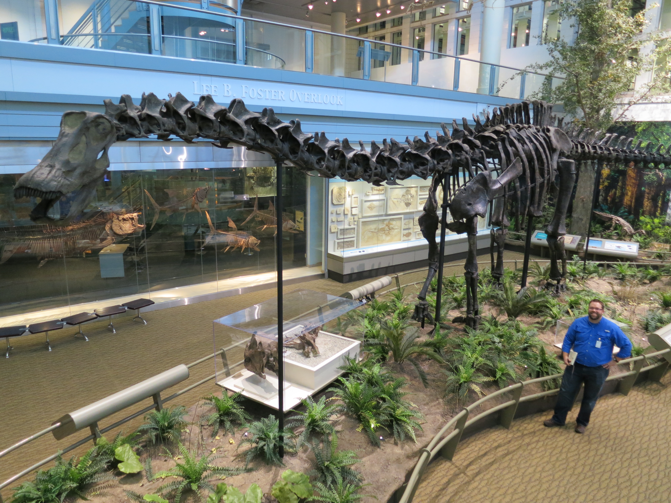

**Figure 2.** The original *Diplodocus* molds created by the Carnegie Museum, shown in the Utah Field House some time between 1953 and 1955. In the background to the left is the mold for the sacrum and coalesced ilia, seen in right ventrolateral view with anterior to the top. In the middle of the foreground is the mold for a posterior cervical vertebra in ventral view with anterior to the lower left. The molds closely follow the shapes of the bones they were modelled from, but are noticeably bulkier. Scanned by Eileen Carr for the J. Willard Marriot Digital Library, image ID 1212242. Used by permission, Uintah County Library Regional History Center.

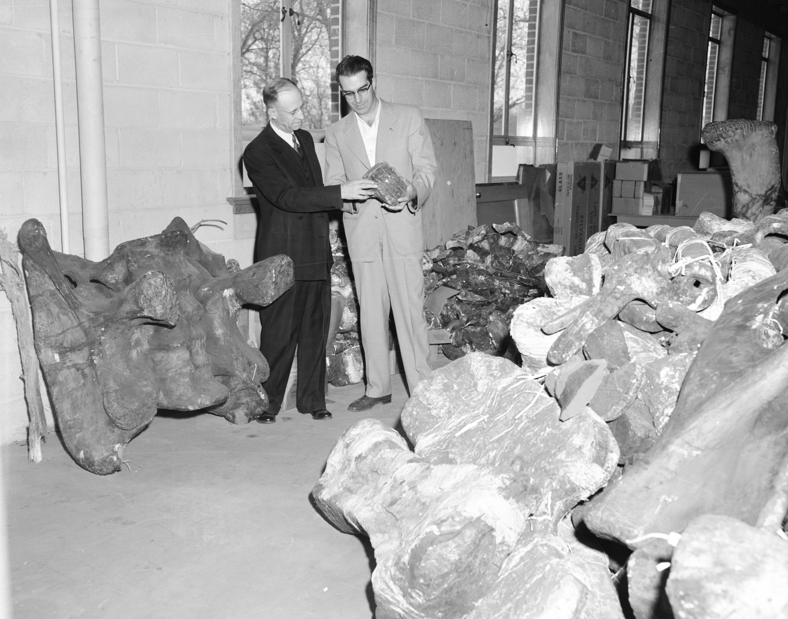

**Figure 3.** Field House Museum director G. Ernest Untermann (left), and his wife, Staff Scientist Billie Untermann (right), grouting the cast dorsal vertebrae of the Field House’s concrete *Diplodocus*. 24 January 1957. Scanned by Aric Hansen for the J. Willard Marriot Digital Library, image ID 1086940. Used by permission, Uintah County Library Regional History Center.

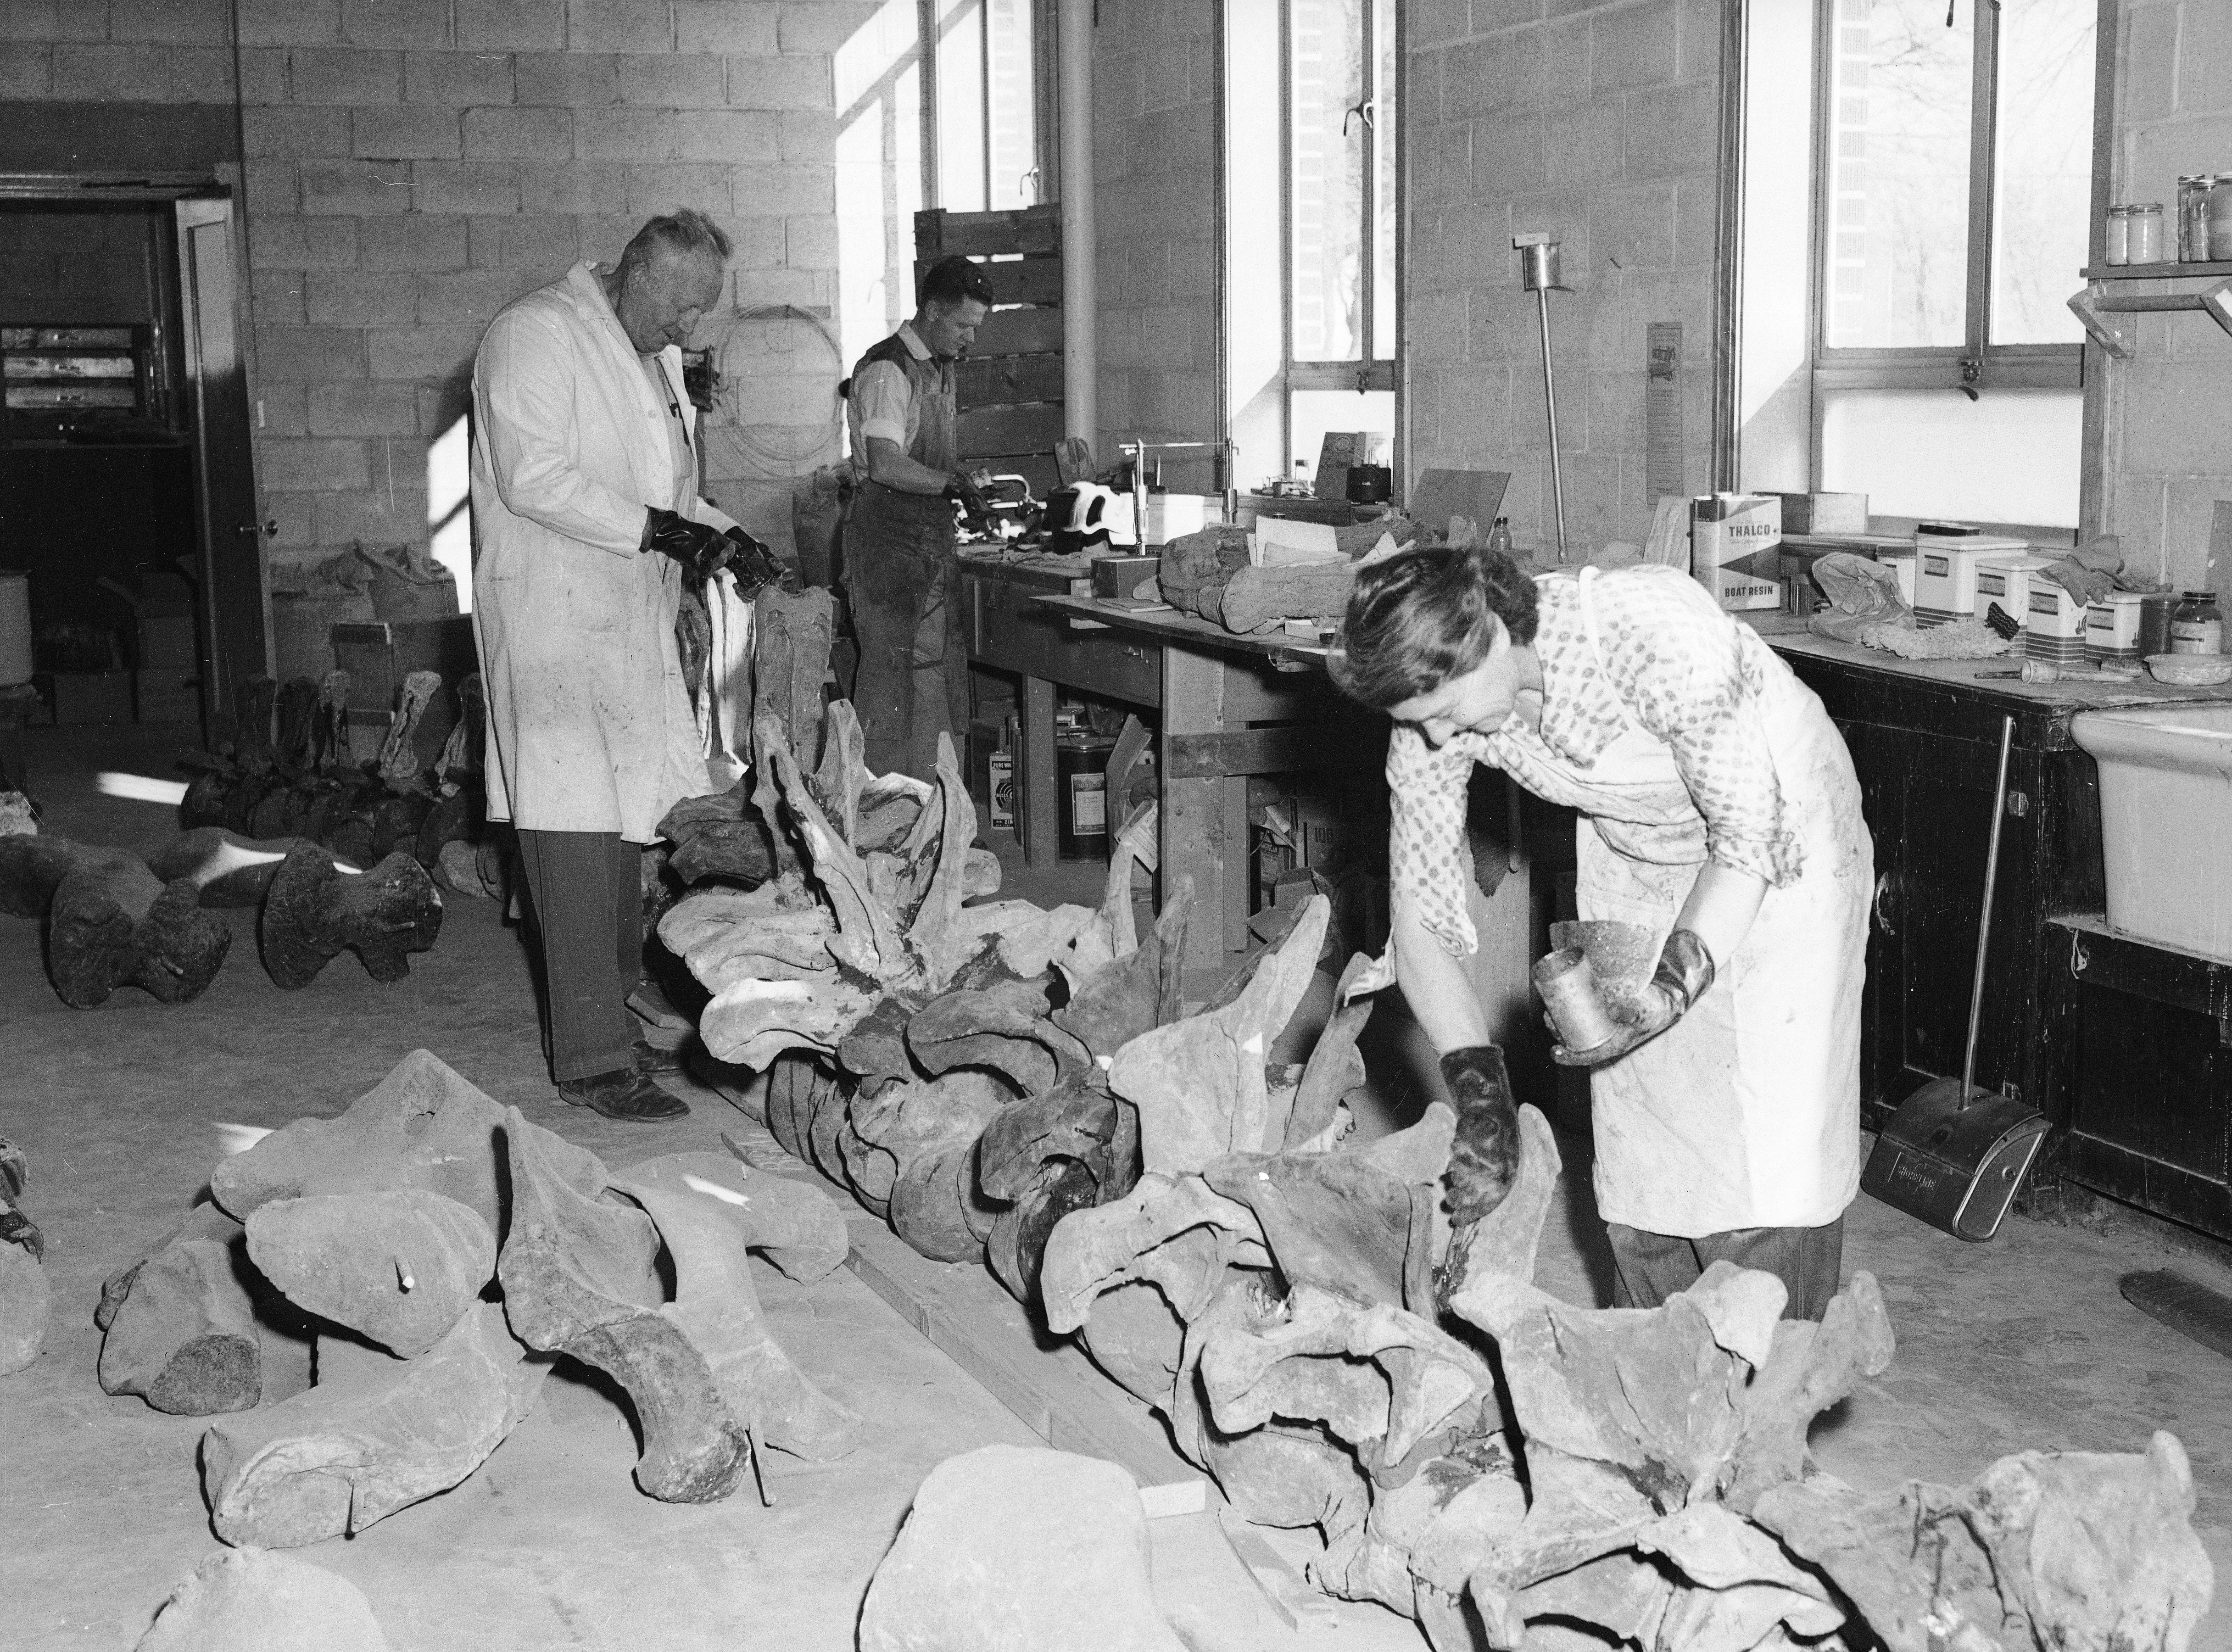

**Figure 4.** Assembly of the outdoor concrete *Diplodocus* at the Utah Field Museum in 1957. **A.** In right posterolateral view. The sacrum and fused ilia having been mounted on the main support to begin the process, the hindlimbs, last four dorsal vertebrae and first caudal have now been added. **B.** In left anterodorsolateral view, probably taken from the roof of the museum. The mount is almost complete, with only the forelimbs, their girdles and the dorsal ribs yet to be attached. Note that, contra Untermann (1959:367–368), the skull is already in place. Both images scanned by Aric Hansen for the J. Willard Marriot Digital Library, image IDs 1090660 and 1090647. Used by permission, Uintah County Library Regional History Center.

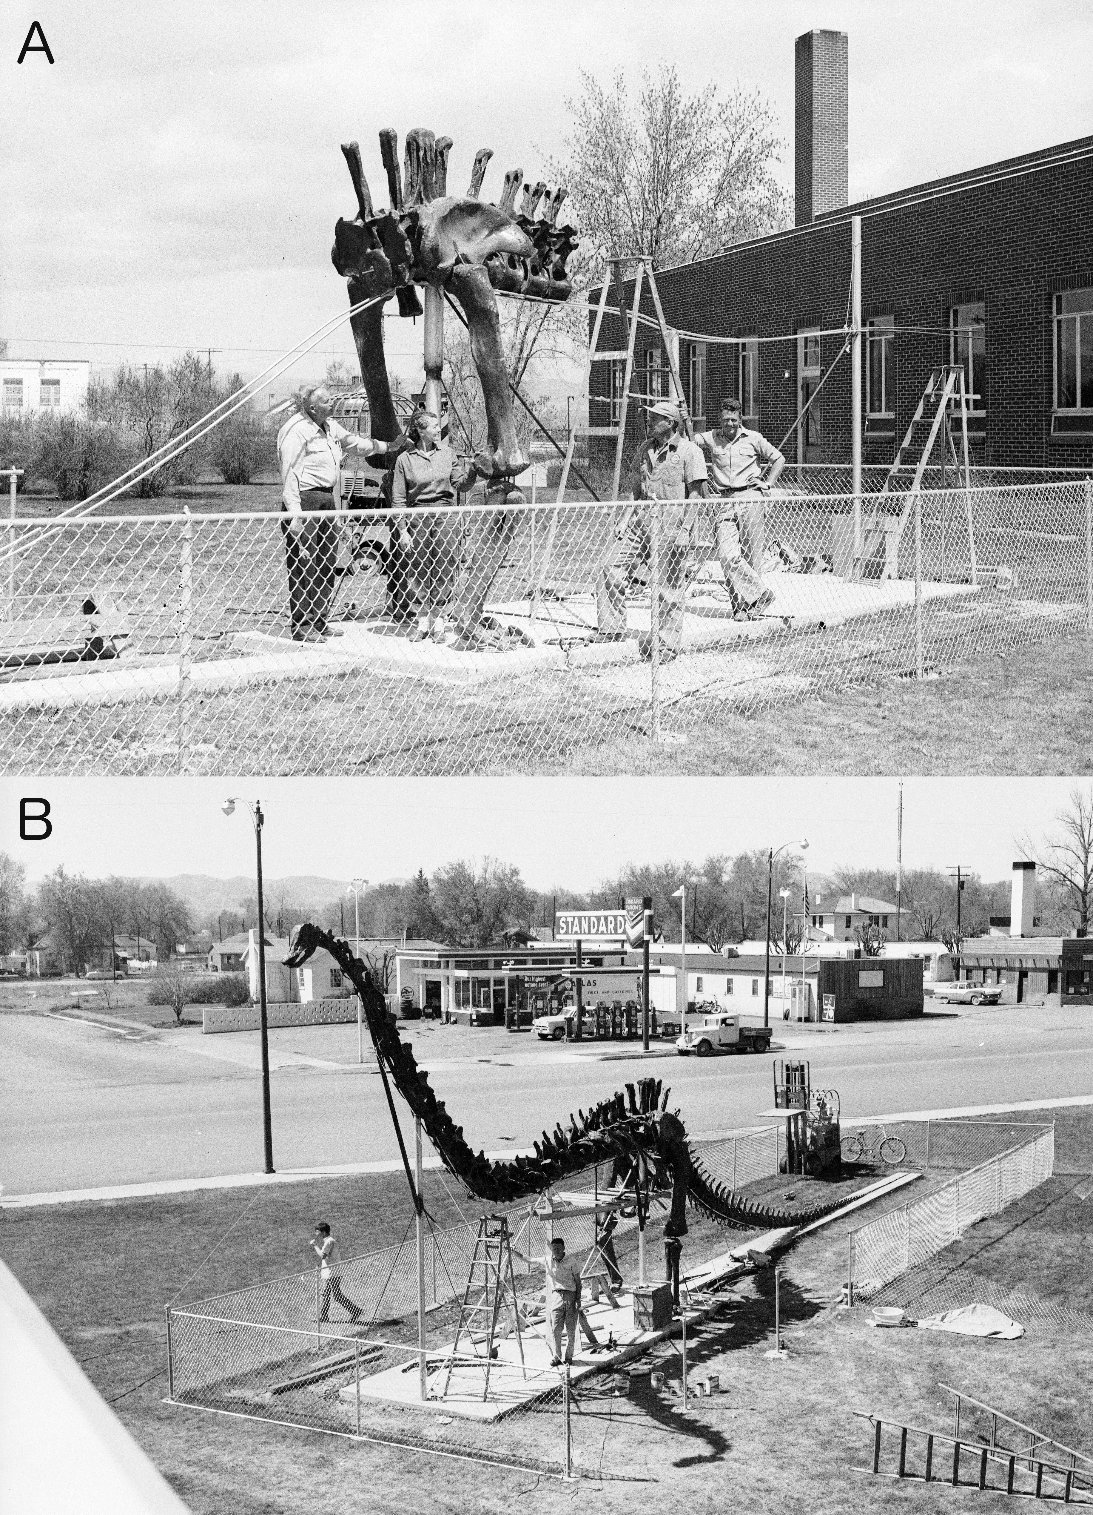

**Figure 5.** The completed outdoor *Diplodocus* mount in a rare colour photograph. Undated. Scanned by Eileen Carr for the J. Willard Marriot Digital Library, image ID 415530. Used by permission, Uintah County Library Regional History Center.

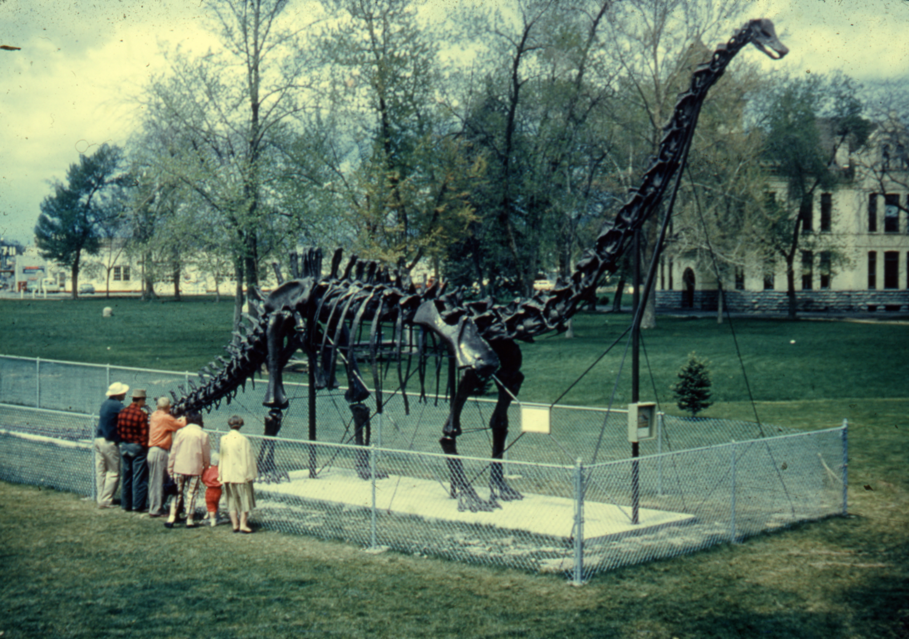

**Figure 6.** The outdoor *Diplodocus* mount is repainted on 22 June 1967, in what was likely an annual event. Field House employee Ivan Hall applies a mixture of linseed oil and brown stain while G. Ernest Untermann holds the ladder. Scanned by Eileen Carr for the J. Willard Marriot Digital Library, image ID 1091738. Used by permission, Uintah County Library Regional History Center.

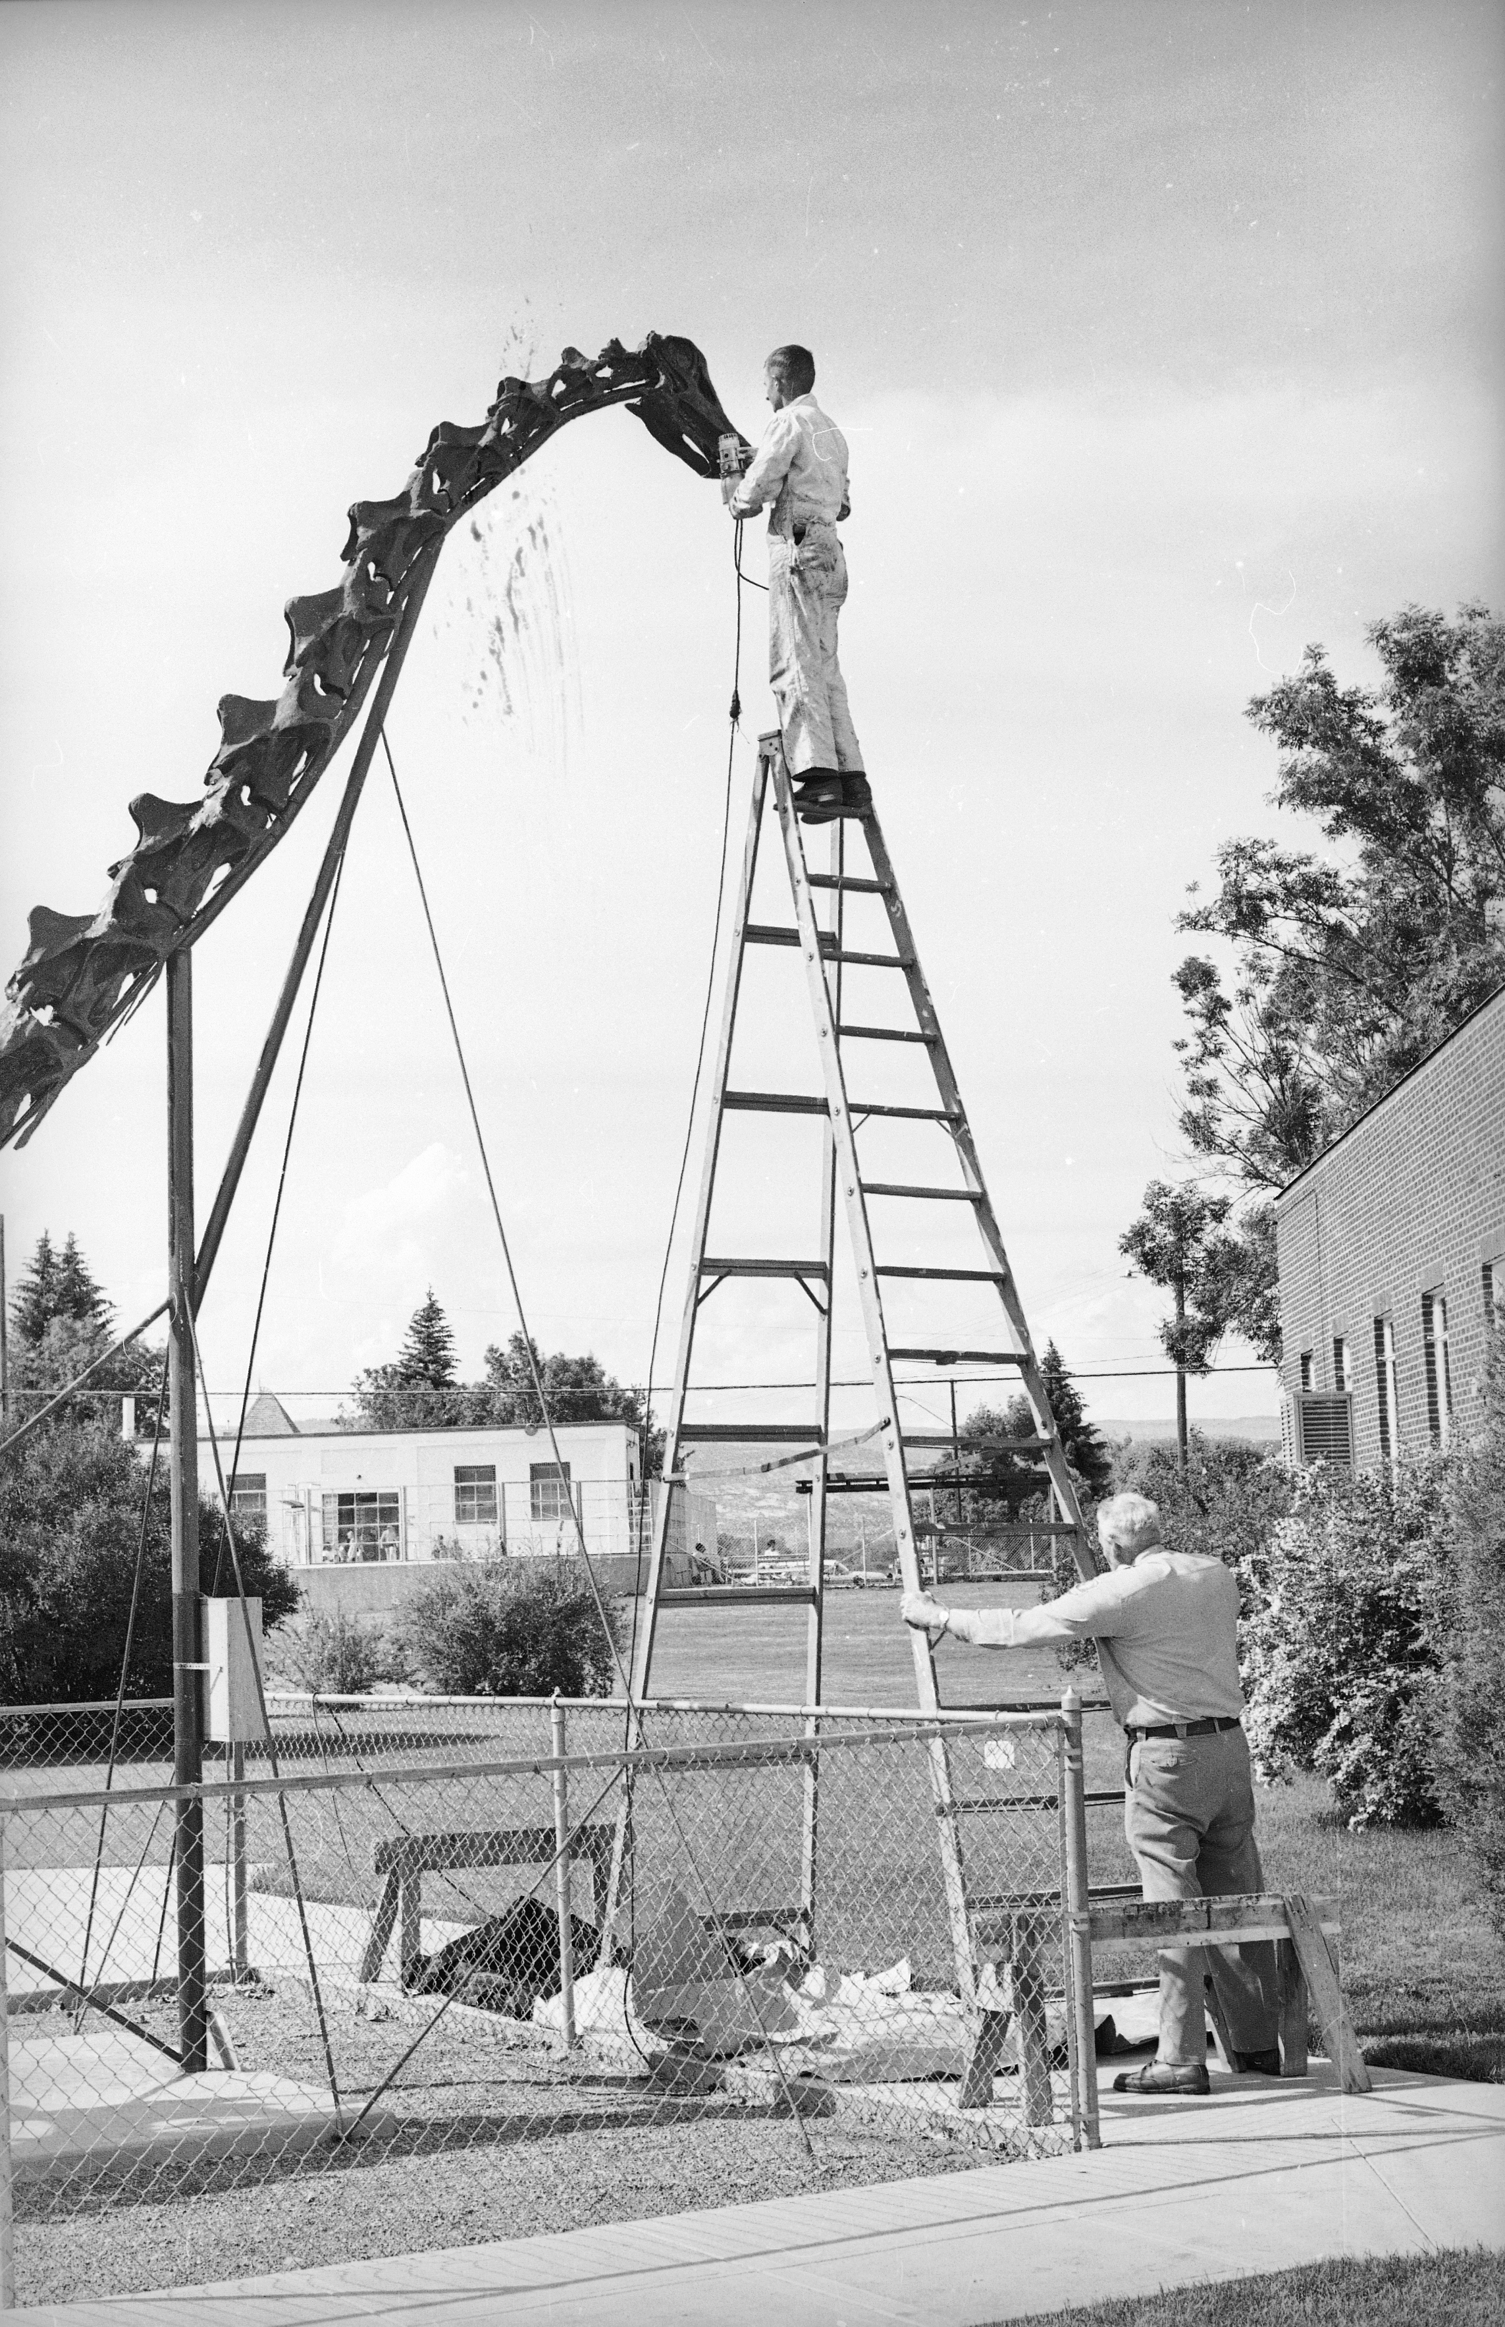

**Figure 7.** The original *Diplodocus* molds being loaded onto a truck for shipment to the Rocky Mount Children’s Museum, North Carolina, on or shortly before 14 July 1960. From left to right: truck driver William Randolph Turnage, Field House employee Dee Hall, and Field House director G. Ernest Untermann. Scanned by Aric Hansen for the J. Willard Marriot Digital Library, image ID 1086142. Used by permission, Uintah County Library Regional History Center.



**Figure 8.** The second-generation lightweight *Diplodocus* cast as originally displayed at the old Field House building between 1994 and 2004. **A.** Right anterolateral view, showing the head and neck projecting above the admission counter; **B.** Left posterolateral view, emphasizing the curvature of the elevated tail necessary to fit the 76-foot skeleton into the 50-foot exhibit hall. Photographs taken in May 1999 by Chet Gottfried, using a Pentax LX camera with a 17mm rectilinear fisheye lens. Used by kind permission.

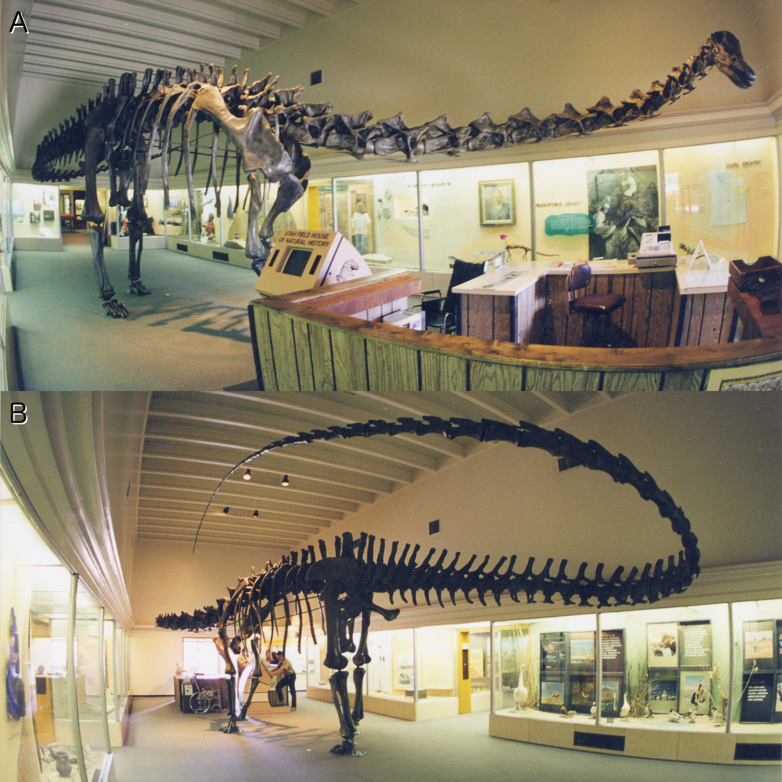

**Figure 9.** The second-generation lightweight *Diplodocus* cast as currently displayed at the new Field House building since 2006. Skeleton in right lateral view, with *Homo sapiens* Michael P. Taylor for scale. Photograph by Mathew J. Wedel.

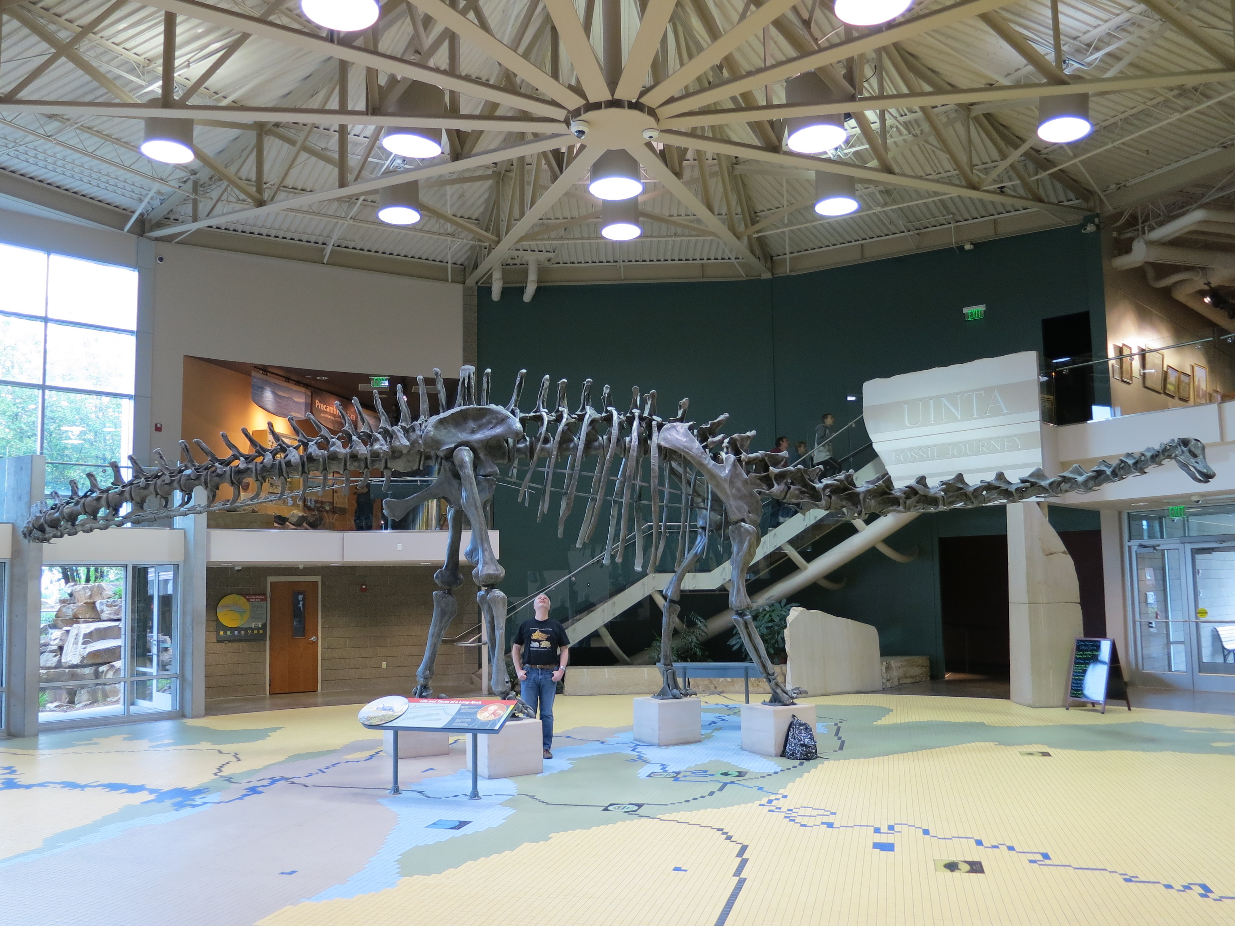

**Figure 10.** Double *Diplodocus* mount at the Museum of Science and Industry (MOSI), Tampa, Florida. Both individuals are identical, having been cast from the molds made by Dinolab from the Concrete *Diplodocus* of Vernal. Photograph by Anthony Pelaez, taken between 1997 and 2017.

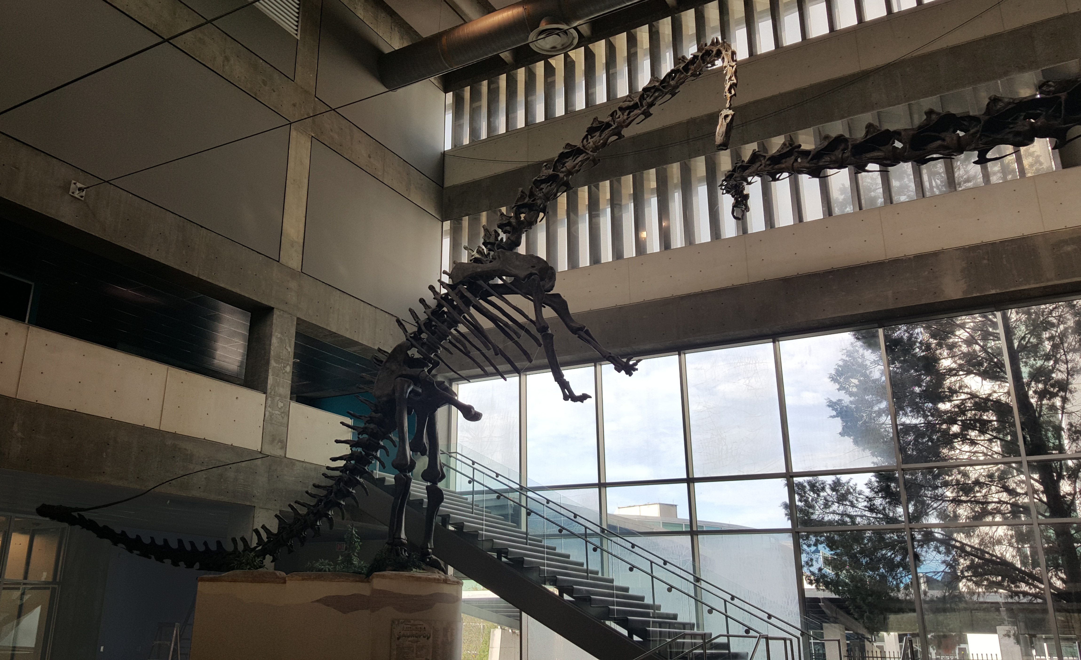

**Figure 11.** The elements of the concrete cast moving from Vernal to Price on 8 April 2013. **A.** the concrete bones packed onto wooden pallets outside the new Field House building, having been been prepared for transportation to the Utah State University Eastern campus in Price, Utah, about 100 miles southwest of Vernal. Photograph by Steven D. Sroka. **B.** The same bones having been unpacked into Ken Carpenter’s garage in Price. Photograph by Ken Carpenter.

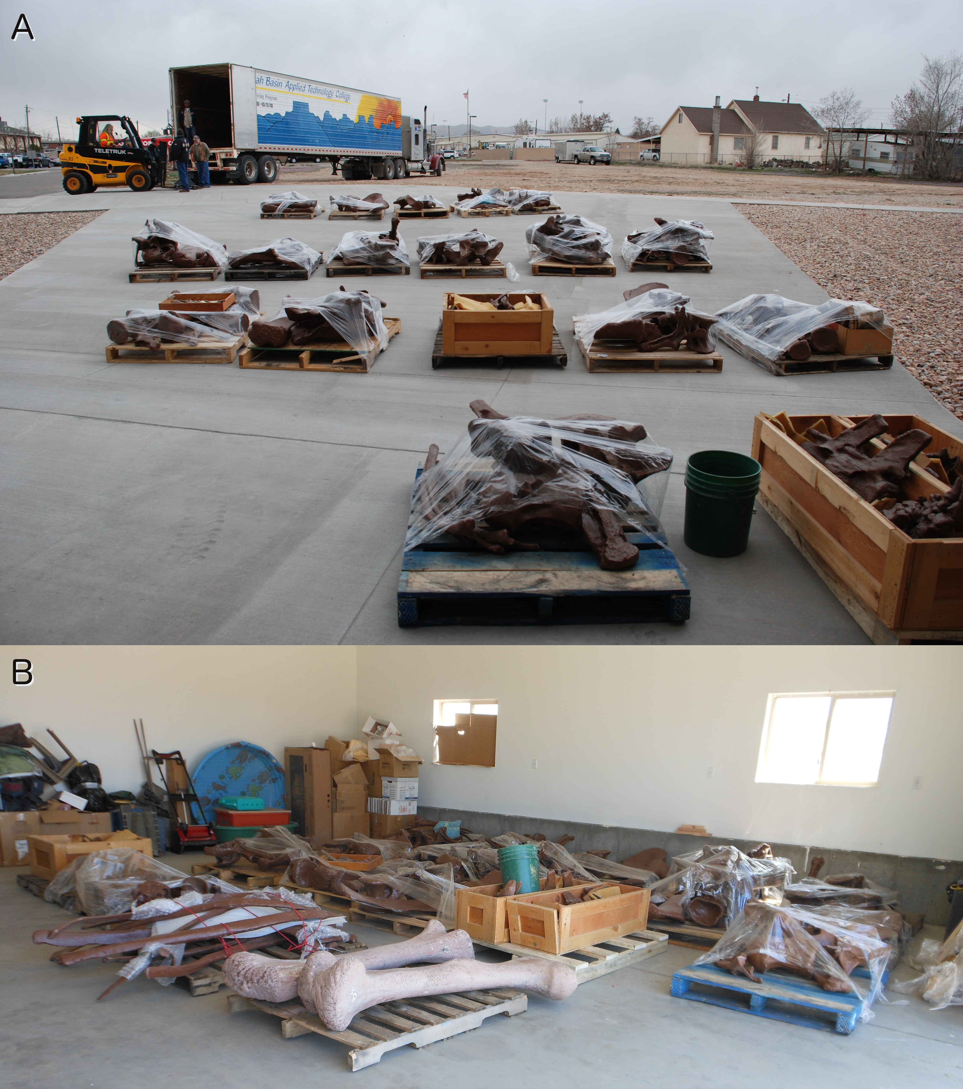

**Figure 12.** Carrie Herbel, a preparator at the Prehistoric Museum in Price, sandblasting old paint off the concrete *Diplodocus* casts recently obtained from Vernal, on 1 November 2014. By comparison with Hatcher (1901:plate V), which shows anterior-view photographs of the cervical vertebrae of *Diplodocus carnegii* holotype CM 84, this appears to be the cast of the 15th and last cervical, based on the wide zygapophyseal facets, the broad diapophyseal wings, the well-developed “V”-shaped intraprezygpophyseal lamina, and the tall, well separated halves of the bifid neural spine with little dorsal expansion.

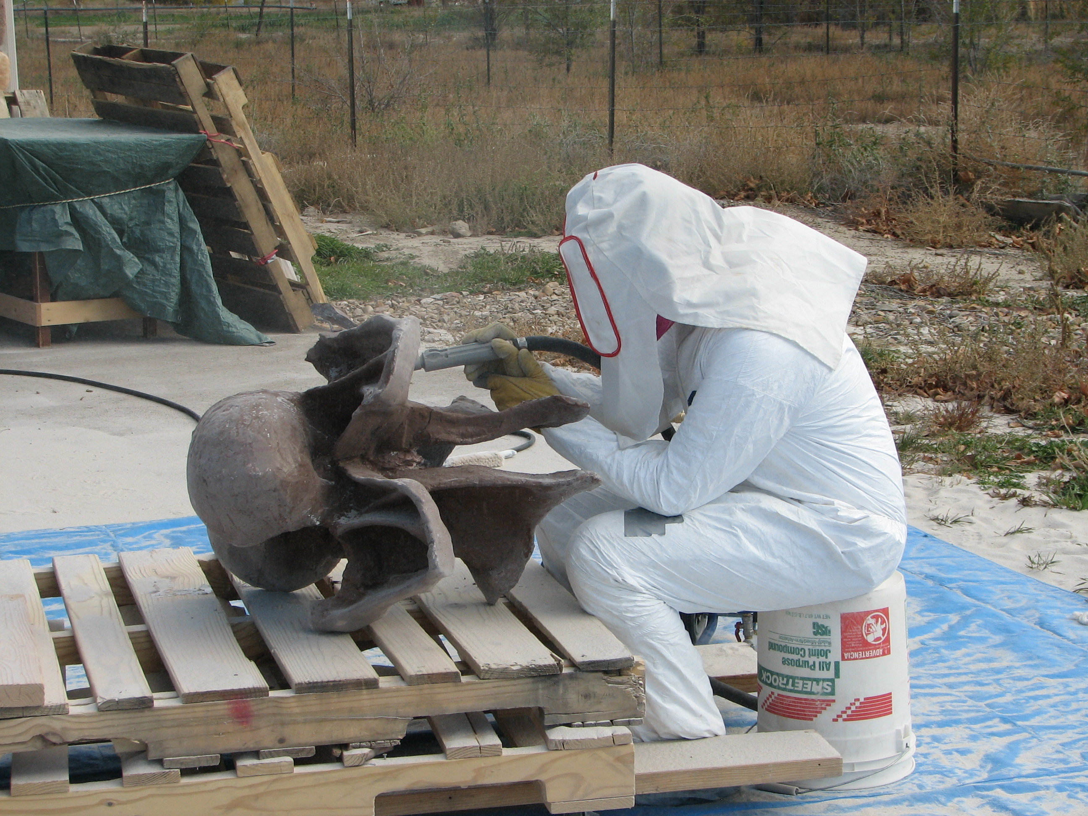

**Figure 13.** The elements of the concrete cast as they are now, having been cleaned and stored in in the basement storage area on the Utah State University Eastern campus in Price, Utah.

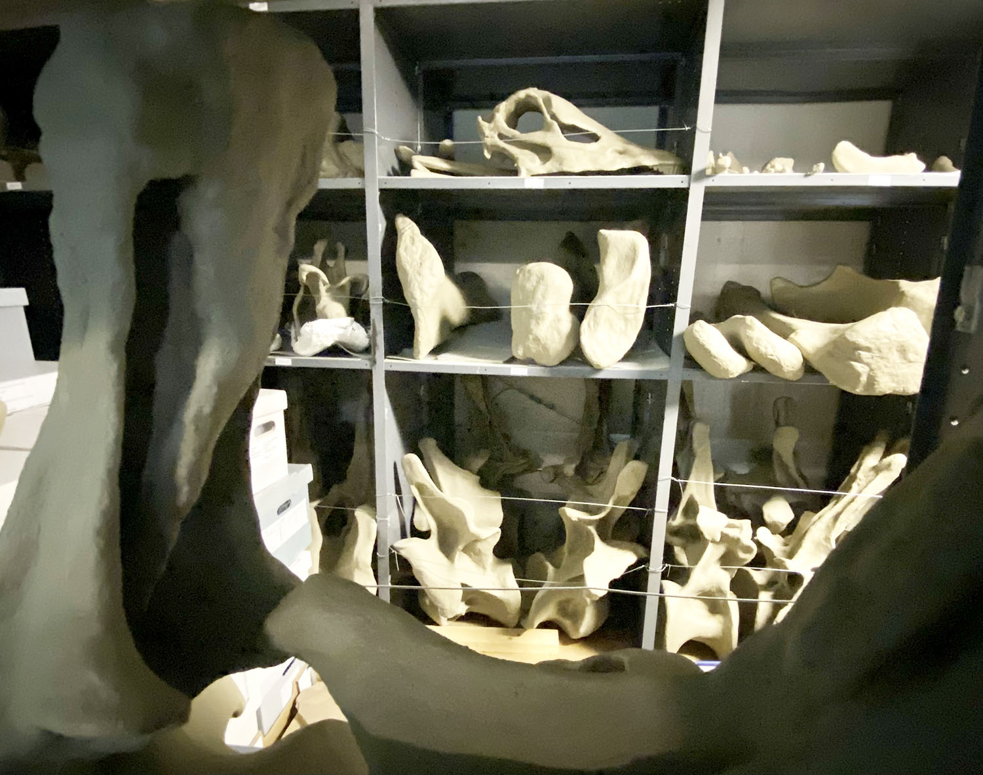

# Tables

**Table 1.** Casts made from the molds taken from the concrete *Dipodocus* of Vernal. This table represents a synthesis of three sources of information: a list maintained by Dinolab and forwarded by Brian D. Curtice; James H. Madsen’s (1993) memorandum to Mary Dawson (Carnegie Museum) and Alden H. Hamlin (Utah Field House); and an accounting made by Dinolab to Steve Sroke shortly after he started work at the Field House (Dinolab 2001). The first of these lists specific cities that the casts were sent to, includes dates, and extends to #13; the second lists only the first four casts, lists clients, gives regions rather than cites, and notes what royalties were paid; the third notes where payments were made “in kind” as contribution towards the cost of a *Stegosaurus* cast. Note that Dinolab’s numbering of the casts does not proceed in chronological order, and that casts 9–12 are not recorded in the available documents.

| **#** | **Date** | **Client** | **City** | **Region** | **Country** | **Royalties paid** | |
| --- | --- | --- | --- | --- | --- | --- | --- |
|  |  |  |  |  |  | **Field House** | **Carnegie** |
| 1 | January 1990 | Meitetzu | Odawara | Kanagawa | Japan | $5,000 | N/A |
| 2 | October 1992 | Meitetzu | Shiramine | Ishikawa | Japan | $5,000 | N/A |
| 3 | May 1992 | Mitzukoshi | *(Travelling exhibit)* | | Japan | $5,000 | $3,500 |
| 4 | June 1992 | RCI | Shimizu | Tokai | Japan | $5,000 | N/A |
| 5 | May 1991 | Alden Hamblin | Vernal | Utah | USA | (Towards *Stegosaurus*) | N/A |
| 6 | February 1998 | Aurora Oval | Tokyo |  | Japan | (Towards *Stegosaurus*) |  |
| 7 | October 1998 | David Letasi | Tampa | Florida | USA | (Towards *Stegosaurus*) |  |
| 8 | October 1998 | David Letasi | Tampa | Florida | USA | (Towards *Stegosaurus*) |  |
| 9–12 | *(Not recorded)* | | | | | | |
| 13 | 2006 | The Dinosaur Store | Cocoa Beach | Florida | USA |  |  |